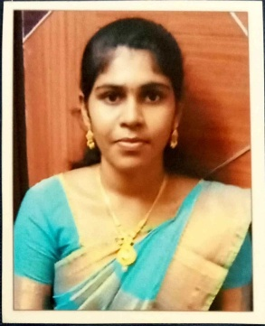
RESUME

Personal details:

Name : U. Sherly

Email Id |  |  | : sherlykumar01@gmail.com
Date of Birth |  |  | : 19.06.2001
Gender |  |  | : Female
Nationality |  |  | : Indian
Religion |  |  | : Christian
Languages Known |  |  | : English and Tamil
Address |  |  | : 22/A, Fatima Nagar, 2nd Street,
Thoothukudi
628003
Mobile Number : 9786275946

Career Objectives:
A dedicated and detail-oriented individual looking for a of Dietitian at a well-reputed organization to gain experience and exposure and expand my knowledge. To secure a challenging position in a reputable organization to expand my learnings, knowledge, and skills. Seeking an opportunity to use my skills as a Dietitian to develop individualized meal plans for clients based on their specific dietary needs.

Academic Qualification:

Degree |  | Year of  passing | Major | Institution | Percentage
Master  Science  (M.Sc) | of | 2021-2023 | Dietetics and food management | Holy Cross Home Science  College,  Thoothukudi | 83.22%
Bachelor of Science(B.Sc) |  | 2018-2021 | Chemistry | St. Mary’s College | 81%
(Autonomous)
Thoothukudi
Higher  Secondary |  | 2016-2018 | Pure Science | Holy Cross Girls Higher  Secondary  School | 90.91%
SSC |  | 2011-2016 | General | Holy Cross Girls Higher  Secondary  School | 97.4%

Professional skills:

- Have excellent communication and instruction skills
- Communicate effectively both verbally and in writing.
- Ability to speak in both English and Tamil.
- Collaborating with others to achieve common goals.
- Analyzing situations and finding effective solutions.
- Flexibility in adjusting to new situations and changes.
- Working knowledge with computer and internet.

Computer skills:

Proficiency in MS Office(MS Word,Excel and Power point).

Internship:

Completed an one month Internship for Dietitian at Dr.Muthus Multi-speciality Hospital, Coimbatore.

Teaching experience:

June 2023- December2023: Been a guest lecturer for B.Sc Food Science and Nutrition students in Holy Cross Home Science College,
Thoothukudi

Course taught: Diet Therapy , Public Health Nutrition, Food Chemistry and Chemistry .

Declaration:

I here by declare that all the above information's are true to the best of my knowledge.

