CURRICULUM VITA
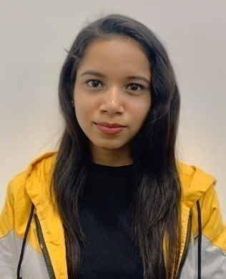
DIPA DEB
Contact No. +919330627073/+917086509845
Email Address:- dipadeb982@gmail.com
Residential Address:- Bhangagarh, Srimantapur near Assam Police Border Headquarters, Guwahati-781032 (Assam)

CAREER OBJECTIVES

To work with a reputable company, where I can prove my capabilities through hard work and team play and also by utilizing my training & skills, while contributing for the success of the company.

PERSONAL SKILLS & STRENGTH

- Good communication skills, confident, self-motivated & goal oriented.
- Adaptive to different environment and effective team work.
- Has the ability to work under pressure with positive attitude.
- Has leadership qualities and is able to cooperate with any given situation.

ACADEMIC CREDENTIAL
Specialization: Bachelor of Business Administration (Hon.)
QUALIFICATION | INSTITUTE | BOARD/ UNIVERSITY | YEAR OF PASSING
10TH | MAHARISHI VIDYA MANDIRPUBLIC SCHOOL | C.B.S.E | 2017
12TH | FACULTY HIGHER SECONDARY SCHOOL | C.B.S.E. | 2019
B.B.A. | NARULA INSTITUTE OF TECHNOLOGY | M.A.K.A.U.T. | 2022

PROFESSIONAL ATTAINMENT

- Internship training on Digital Marketing.
- Internship training on Financial Markets.
- Internship training on Financial Modeling and Valuation.
- Internship training on Tally.
- Experience on ‘Customer Service Associate’ about 6 months in Tech Mahindra.

ACHIEVEMENT SKILL

- Achieved ‘Yuva Leadership Certificate’ at Yi Yuva Conclave.
- Achieved certificate for active participation in the ‘Innovative Marketing Challenge’ at Yi Yuva Conclave.
- Achieved certificate for attending a webinar session on ‘Panel Discussion on Higher Education’ at Yi Yuva Conclave.
- Achieved certificate for attending a webinar session on ‘Masterclass on Design for your Business’at Yi Yuva Conclave.
- Achieved Certificate for attending a webinar session on ‘Enterpreneurship Panel Discussion’ at Yi Yuva Conclave.

TECHNICAL SKILL

- Ms-Office
• Macromedia Flash
• CorelDraw
• HTML
• Tally–ERP9
- Excel

- CRM

PERSONAL DETAIL

- Date of Birth: 3rd October 1999
- Gender: Female
- Nationality: Indian
- Religion: Hindu
- Marital Status: Single
- Interest: Drawing, dancing, listening to music and travelling
- Language known: English, Hindi, Bengali, Assamese

Declaration: I hereby certify that the particulars given by me in this resume are to the best of my knowledge and belief.

Date: 22-02-2024

