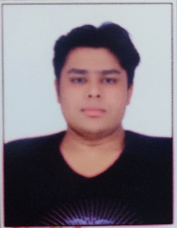
RESUME
Ryan Marian Sunil Mascarenhas
Email id: ryanmascarenhas086@gmail.com
Mobile No: 8169493861.
Address: Citizen Snowdrop, B/7, B/Wing,
Room No: 306, Naigaon (E) 401208.

CAREER OBJECTIVE
- Obtain a responsible position in an organization with the best capabilities, skills and knowledge.

ACADEMIC QUALIFICATION:
- 12th from Thomas Baptista Jr. College.
- 10th from Don Bosco High School.

PROFESSIONAL SKILLS:
- Graphic Designing.
- Gaming

WORK EXPERIENCE:
- Fresher

PERSONAL DETAILS:
Father’s Name : Sunil Mascarenhas
Date of birth : 11th January 2003
Gender : Male
Nationality : Indian
Marital Status : Unmarried
Languages Known : English (can understand hindi a little bit but I can’t talk)
Hobbies : Playing Video Games (Especially games from RockstarGames)

