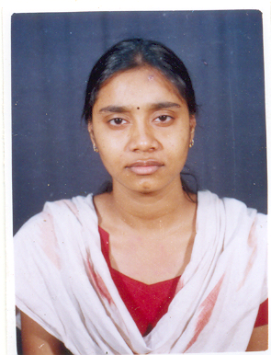

RESUME

PERSONAL PROFILE

NAME : DIANA JOSEPHINE GOMES

HUSBAND’S NAME : MR. SURAJIT ANIL GOMES

PRESENT ADDRESS : 84/3 P.K GUHA ROAD, SRISTI APARTMENT,
FLAT-1F/22, 1ST FLOOR, KOLKATA-28
DUMDUM CANTONMENT. WEST BENGAL

CONTACT NUMBER : 0091 9163124511 / 9831060140 .

DATE OF BIRTH : 10 AUGUST, 1981.

NATIONALITY : INDIAN.

MARITAL STATUS : MARRIED.

PASSPORT NO -- : M2004605 (DATE OF ISSUE -05/09/2014) (DATE OF EXPIRY- 04/09/2024)
PLACE OF ISSUE – KOLKATA .

EDUCATIONAL PROFILE

QUALIFICATION : B. Sc. [BOTANY HONOURS]
B. Ed. [ LIFE SCIENCE & PHYSICAL SCIENCE]
M.A [ENVIRONMENTAL STUDIES]

SCHOOLS & COLLEGES : LORETO CONVENT ENTALLY
ATTENDED LORETO HOUSE
SCOTTISH CHURCH COLLEGE

St. XAVIER’S COLLEGE

SUBJECTS : BOTANY (HONS.) , CHEMISTRY, ZOOLOGY, ENGLISH, BENGALI
ENVIRONMENTAL STUDIES

EXTRA QUALIFICATION : DIPLOMA IN COMPUTER APPLICATION & PROGRAMMING.

LANGUAGES KNOWN : ENGLISH , BENGALI , HINDI

CAREER PROFILE

EXPERIENCE : WORKING AS SCIENCE TEACHER IN MISSIONARY SCHOOL,
KOLKATA. FOR – 17 YEARS

EXPECTED REMUNERATION : NEGOTIABLE

--------------------------------------------------
DIANA JOSEPHINE GOMES

