- 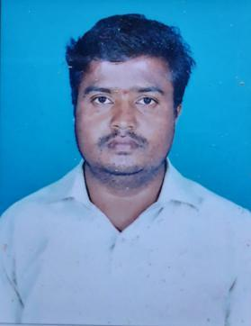
Mahantesh S Annigeri
Info
Address:
Anjaney Nagar, Goa Road
Dharwad-580008

Nationality
Indian
Phone
+91 9483667818

Email
HYPERLINK "mailto:mahanteshannigeri1982@gmail.com" mahanteshannigeri1982@gmail.com

Professional Summary
- 10+ years experience in civil construction.
- 4+ years experience in electrical.
- Proficiency in driving, heavy batch vehicles also.
- 6 months Sales experience in Shantesh Honda Showroom
- Working in Attica gold company from 6 months

Educational Details:
Basel Mission Comp PU College Dharwad
Jun 1998– Jun 2000
Pursued Intermediate of Electric Wiring and Ser of electric appliances from Basel Mission Comp PU College,with 53.62%.
Karnataka High School, Matriculation
Jun 1994 - Jun 1998
Completed Matriculation from Karnataka High School, Dharwad.
Personal Details
Date of Birth : 19th March 1982
Marital Status : Married
Language Knows : Hindi, English, Kannada

Acknowledgement
I hereby declare that all the above provided information is true to the best of my knowledge.

Date:
Place:

