CURRICULAM VITAE
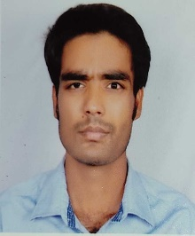
Rakesh Kumar
Dak Banglow Road, Barbatta, Sonepur, Saran, Bihar - 841101

Contact No: - (+91) 7277512374

E-mail id:- rakesh007raushan@gmail.com

Educational Qualification

Education | Course | School/College/University | Passing Year | Percentage
Graduation | BCA | R.N. College/BRA | 2019 | 67.62
Higher Secondary (+2) | Science | P.R. College/BSEB | 2016 | 63.6
High School(10th ) | Matriculation | St. Paul Higher Sec./CBSE | 2014 | 8 CGPA

Work Experience

- Worked in UIDAI from Jan 2020 to March 2020
# Maintain the data of UIDAI
- Worked in Flipkart as a DEO from 11 Jul to 15 Nov 2023
# Connect/Unloading the shipment with TC App within TMS
# Maintain OPS Tracker

Skills: - C++, Java, Unix
# Taking care of all types of records. Frequently works with Excel, Word & Power Point.

Objectives: -

To be a part of an organization where get a chance to use my knowledge and skills to contribute in the progress of the organization as well as myself.

Personal Details: -

Fathers Name: Chandra Shekhar Thakur
Mothers Name: Indu Devi
DOB: 03-01-1999
Marital Status: Unmarried
Nationality: Indian
Language Known: English, Hindi
Strength: Highly Adoptable, Punctuality.

Interest: - Reading books, Nobles, Magazines, Newspapers, Listening music.

