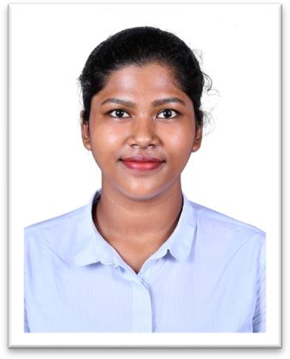

J.K. JOINNER

No 3/14 Morai Elango Nagar

Veerapuram, Avadi,
Chennai 600055.
Phone: 9003142203
Gmail: joinnerjoseph14@gmail.com

OBJECTIVE

Enthusiastic, friendly, motivated and precise to work in customer service-oriented role at McDonald’s. Would love to join a team to utilize my skills and experience with customer service, food preparation, team management, and problem-resolution skills at McDonald’s. Passionate about keeping customers happy and satisfied. I wish to learn, acquire and strengthen my skills to deliver an exceptional customer service to our guests.

ACADEMIC QUALIFICATION

INSTITUTION | YEAR OF  PASSING | PERCENTAGE
Diploma in customer service | 2023 | 85%
Stella Maris college | 2021 | 6.002 %
Kendriya Vidyalaya Crpf Avadi – 12th | 2018 | 8.2 CGPA
Kendriya Vidyalaya Crpf Avadi – 10th | 2016 | 7.6 CGPA

CERTIFICATIONS
- Certified for clearing diploma in computer Application at R-way Education.

LANGUAGES

- Fluency in both spoken and written English, Hindi and Tamil.

WORK EXPERIENCE

- Worked as a food service staff at AP CATERING-Part time (2023)

TECHNIAL (IT) SKILLS

- PC based skills (MS OFFICE/MS EXCEL/E-MAIL)
- Proficient in computer application
- Ability to work accurately in checking and distribution of mails in a timely manner.
- Proficient in answering calls and queries.

SOCIAL SKILLS AND COMPETENCES

- Burger making skill.
- Strong work ethic.
- Strong work ethic.
- Team building skill.
- Administrative support.
- Planning and coordination.
- Exceptional customer service skill.
- Food preparation skill.
- Good communication and interpersonal skill.
- Well organised.
- Collaborative and cooperative.
- Detail oriented.
- Swift grasper.
- Ability to work well with others.
- Ability to perceive the customers.
- Good time management.

PERSONAL DETAILS

Date of birth : 14 July 2001
Gender : Female
Father’s Name : A. Joseph
Nationality : Indian
Eye Color : Black
Height : 5’4

DECLARATION
I hereby declare that all the above-mentioned information given by me is true and correct to the best of my knowledge and belief.

