RESUME
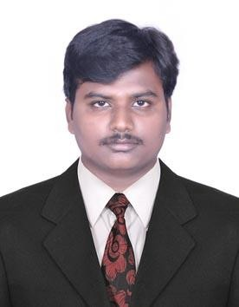
PERSONAL DETAILS
NAME : GUNASEKARAN. P B.tech.
MAIL ID : agsgunapsg@gmail.com
CONTACT NO : +919080081419, 9566807509(whatsapp)
DATE OF BIRTH : 14.06.1994 AGE: 30 sex: MALE
FATHER’S NAME : MR. PALANISAMY .R
MOTHER TONGUE : TAMIL
LANGUAGES: Read : Tamil, English
Write : Tamil, English
Speak : Tamil, English, Hindi.
PERMANENT ADDRESS
Door Number : LIG 2700 ,
Gandhimanagar,
Peelamedu,
Coimbatore,.
Tamilnadu. India ,
Pin Code = 641004

CAREER OBJECTIVE
A challenging career which offers an opportunity to apply my skills knowledge with continuous learning and growth.
WORK EXPERIENCE:

- PUNIT CREATION PVT LTD (BANGALORE)
WORKING PERIODS : May 2015 to May 2017 (2 YEAR)
WOVEN : Shirts, Pant
ROLE : Sr. EXECUTIVE INDUSTRIAL ENGINEER

- BEST CORPORATION PVT LTD (TIRUPUR)
UNIT: EXCEL KNITWEAR (NEW TIRUPUR NAP)
WORKING PERIODS : July 2017 to November 2018 (1.5 years)
KNITS : Baby Wears –Body suits, sleep suits, PJ top and pant, Men’s – polo shirts, R-neck and V-neck
ROLE : Sr. EXECUTIVE INDUSTRIAL ENGINEER

- UNITED CREATION LLC – JORDAN (AZARQ only operators Jordanian)
WORKING PERIODS : January 2019 to July 2021(2.6 years)
KNITS : Men’s – polo shirts, R-neck and V-neck
ROLE : INDUSTRIAL ENGINEER

- GIA APPARELS. AQUBA. JORDAN (classic fashion group)
WORKING PERIODS : January 2022 to march 2024 (2 years)
KNITS : Jacket, winder wear jacket
ROLE : IE Executive
Last 9 years’ experience on this garment industry fully I have experience on the garment production floor and production planning, follow the T&A, make OB and Layout for future styles working R&D for better production and also supporting all department like from the merchandising to finishing team to do the role work study and costing factors, consumption minimizing, manpower allocation to each department as MMR 1:1.15 ,control the factory cost to meet the factory CM cost .

EDUCATION QUALIFICATION
COURSE | INSTITUTION | BOARD/ UNIVERSITY | YEAR OF COMPLETION | GRADE
B. Tech (FASHION TECHNOLOGY) | PSG College of Technology | Anna University | 2015 | 6.79

COMPUTER PROFICIENCY:
  - Packages : Adobe Photoshop,
Corel Draw
PRO SMV MS office

DECLARATION:

I, P.GUNASEKARAN confirm that the information given above is true to the best of my
Knowledge.
SIGNATURE

P.GUNASEKARAN

