RESUME
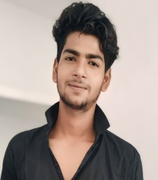
MOHIT TIWARI
+916386850379
Email Id: mt167477@gmail.com
Vill/Post- Bhanpur Sarawan Tarabganj,Gonda UP-271403
OBJECTIVE
Aspiring web developer seeking an entry-level position to utilize my skills in fron-end and back-end development contributing to a dynamic team and enhancing my expertise in web technologies
EDUCATION
- 10th Passed from UP Board in 2020
- Diploma in Computer Science & Engineering [Appearing 3rd Year]
INTERSHIP
Web Development Intern
[Mecatredz Technology Pvt.Ltd Lucknow] [Lucknow, Uttar Pradesh]
[Aug 2023 – Sep 2023]
- Assisted in the development of responsive web pages and user interfaces.
- Collaborated with the team to troubleshoot and debug issues.
- Gained practical experience in version control using Git.
SKILLS
- Programming Language : HTML , CSS , JavaScript , C , C#
- Web Technologies : ASP.NET
- Database : My SQL , Microsoft SQL
- Tools : Visual Studio Code 2012, 2022
PROJECT
Portfolio Website
- Designed and developed a personal portfolio website showcasing project and skills.
- Implemented responsive design for optimal viewing on various devices.

