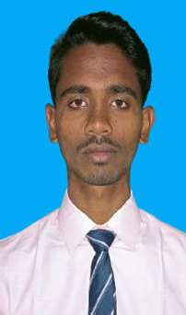
AMAN KUMAR

Mobile:8400831933
E-mail:kumaraman221208@gmail.com, Address:Nathpur Post-Garakhara Varanasi UP-221208

CAREER OBJECTIVE
- Seeking a challenging position in industry where I can utilize my skills to contribute in the growth of the company.

BASIC ACADEMIC CREDENTIALS

Qualification | Board/University | Year | Percentage
Diploma in Electrical Engg. | BTEUP | Appearing 2021-2024 | 75.04%  5TH SEM
Intermediate | U.P.Board | 2021 | 66%
HighSchool | U.P.Board | 2019 | 66%

TECHNICALSKILL

S.No. | CourseName | CourseDetails | Duration | InstituteName
1:- | CCC(Cource on computer concept) | Basic knowledge of computer, | 3.Month | BIPE Gajokhar Varanasi
2:- |  | Basic knowledge of word, excel, power point.

SUMMER TRAINING

I have done vocational training in diploma in Electrical Engg. from33/11 KV Lal bahadur shastri international airport babatpur varanasi (U.P.)(July–August)-2023

CO-CURRICULAR ACTIVITIES&ACHIEVEMENTS

I was secured 1st prise on pragyan rover

I was secured2 ^{st}prise during ppt on mahatma Gandhi jayanti

I was participating in speech ‘On Emgineer Day’

Successfully participating in ‘Photography held in College’

PERSONALDOSSIER

DateofBirth :-

Father’sname :-

Nationality :- LinguisticAbility :-
25th may2004
Mr.Chandresh Ram Indian
Hindi,English

HOBBIES&INTEREST

Playing football & travelling

STRENGTH

Goal oriented, Good Planer, Quicklearner, Friendly

DECLARATION

I am declaring that the above information is true to the best of my knowledge

.Aman kumar
Place - Varanasi

Date-...................



