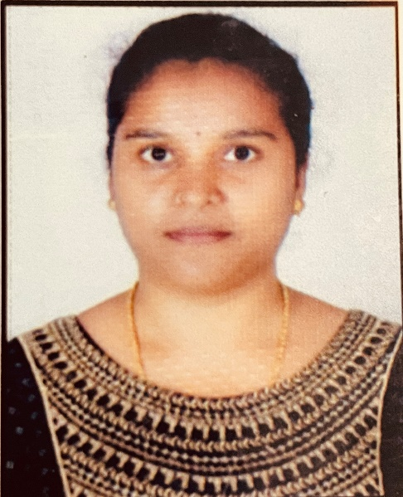
SRAVANI RATTI

Address: 13-50-56
Compostcolony,
Zillaparishad,
Srikakulam,
PhoneNo: +91 9100405646
Email Id: sravani.ratti@gmail.com

- CAREER OBJECTIVE

To be able to work for an encouraging and stable company that will assist me in developing, improving, and obtaining the necessary skills in order to become the best possible. I am looking forward to challenging my potential and be worthy of Management trust and confidence.

- EDUCATIONAL QUALIFICATION
Qualification | Institution | University/board | Year of passing | Percentage
BSC(bzc) | Andhra university | Andhrauniversity | 2022 | 62
DMLT | Stmary’s labtechnical institution | Paramedical board | 2020 | 63.5
Intermediate | Srichaitanya junior kalasala | Board of intermediate | 2013 | 80.7
SSC | Snowwhite vidyalaya | Board of secondary education | 2011 | 65.33

- SKILLS
- Course on ms.office
- hardworking
- Communicationskills
- Leadership
- Experience
Covid duties from 7/2020 to 10/2020 govt general hospital
Clinical training in govt general hospital

- PERSONAL PROFILE
Husband’s Name : harishankar
Date of Birth : 29-12-1995
Language Known : English, Telugu,hindi
Sex : Female
Marital Status : married
Nationality : Indian
Strengths : Quick learner, self-motivated

DECLARATION:
I hereby declare that the details above are correct and true to the best of my knowledge.
Signature
Sravani.R

