CURRICULUM VITAE
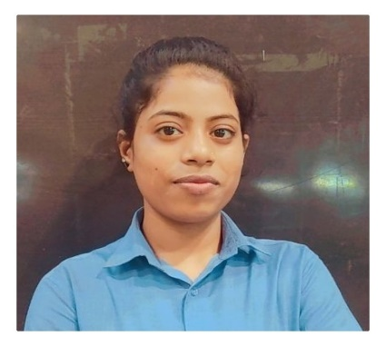NISHAVERMA
Diploma-Metallurgy Engineering
Contact No. :-9179294633 / 7223009744
E-mail:- nishaverma4537@gmail.com

Permanent Address:
J.P. Nagar camp 2 BHILAI,Ward 21
DURG, Chhattisgarh
Pincode-490001
CAREER OBJECTIVE:
To work in a firm with a professional work driven environment where I can utilize and apply my knowledge, skills which would enable me as a fresh graduate to grow while fulfilling organizational goals.

SYNOPSIS:
- A seasoned professional with 3.5 years of rich experience in production process improvement and Manpower Management in Manufacturing Sector. 
- Work experience in production of final finished tyre. 

CURRENT EXPERIENCE:
- Working with CEAT Ltd. Nagpur Maharashtra from Feb.2020 to till date. 
- Designation: Process Associate (management executive) 
- Area: production process in Two &Three Wheeler final finished tyre. 

BASIC ACADEMIC CREDENTIALS:

 | Qualification | Institute Name | Board/University | Year | Percentage
 | Diploma(Meta) | Uday Prasad Uday Govt.Polytechnic, DURG | CSVTU | 2018 | 72.02%
 | 12TH(PCM) | Rastriya high secondary school, BHILAI | CGBSE | 2015 | 63.3%
 | 10TH | Rastriya high secondary school, BHILAI | CGBSE | 2013 | 61.3%
IT PROFICIENCY:
- Microsoft Office Word, Microsoft Office Excel, Microsoft Office Power point.
- MSCIT Course.   

KEY DELIVERABLES:-
(A)OPERATION:
- Achieve defined production targets while meeting the specified quality standards.
- Skill development among the fresh diploma associates in making the machine more efficient and productive.
- Responsible for OEE calculation.
- Responsible for 5S and initiatives in the final finishing area.
- Responsible for Kaizen.
- Responsible for autonomous maintenance.
- Responsible for muri reduction.
- Responsible for SQPDCM. (B)Man Management:
- Working on succession planning of the workforce, shift management activities, appraising the member’s performance & providing feedback. 
- Responsible for manpower handling and scheduling. 

TRANING DETAILS:

Industrial Training Phase ( I ) | Date : 17/07/2017 to 29/07/2017  In Bhilai steel plant at RCL ,BFs, CO&CCD
Industrial Training Phase ( II ) | Date : 26/12/2017 to 06/01/2018  In Bhilai steel plant at BFs, SMS-2, foundry & pattern shop
- Basic first-Aid training from CEAT LTD
- Industrial safety training from CEAT LTD
PERSONAL DETAILS:
Father’s Name : - | Mr. Vrindanand Verma 
Date of Birth : - | 1 JULY 1998 
Language known : - | English & Hindi 
Marital Status : - | Single 
Nationality/Religion : - | Indian / Hindu 
Hobbies :- | Dancing, gardening 
Strength :- | Friendly behaviour, Team player, Hard Working 
DECLARATION:
I hereby declare that the above mentioned information is correct up to my knowledge and I bear the responsibility of correctness of above mentioned particulars.
Place: Nagpur NISHA VERMA
Date: (signature)

