SKILLS
- Supervisory management
- Security and manpower management
- Fire and safety management
- Operations management
- Communication and computer skill
- Quick learner
- Keeping good relations with other departments.
- Time management and handling pressure situations.
- All type of radio sets and Exchange operating
ARMY SERVICE MEDALS
- 20 years good conduct medal
- 75 years independence day medal
- OP rakhsak
- CI OPS jammu and Kashmir medal
- UNMISS medal
personal details
- mob no – 9834400462
- Email –kumarkokate@gmail.com
- dob-06/01/1982
- address
at kokatewadi
post mudhale
tehl baramati
dist pune
pin 413102

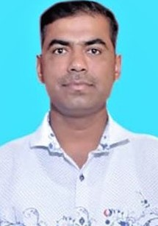 |  |  | kokate kumar madhukar  INDIAN ARMY VETERAN  OBJECTIVE  Indian Army veteran with 22 years of experience and having management skills and computer knowledge. Served in United Nations piece keeping mission in south Sudan. Looking to work in an environment which encourage me to succeed and grow.  Education  - Passed 10th 12th class with first class from state board of Maharashtra.  - Bachelor of Arts with specialisation in History.  - Certificate in security of strategic installations.  - Diploma in security management.  - Associate degree in arts.  - Army graduation ( equivalent graduation from Indian Army)  - Industrial training institute fitter trade  - Military college of telecommunication engineering regimental signal instructor course  - Maharashtra state certificate in information technology (MS-CIT)  KEY PERFORMANCE AREA  - ADM and Technical NCO & PL HAV  - Protocol / liaison office  - Store keeping  - Tele operating  - Security asst officer  - PL HAV  - Coy quarter master  - Supervision  Leadership  I have shown exemplary leadership while leading my platoon in field area and piece areas.  CHARACTER  - Exemplary  LANGUAGES KNOWN  Marathi Hindi English



