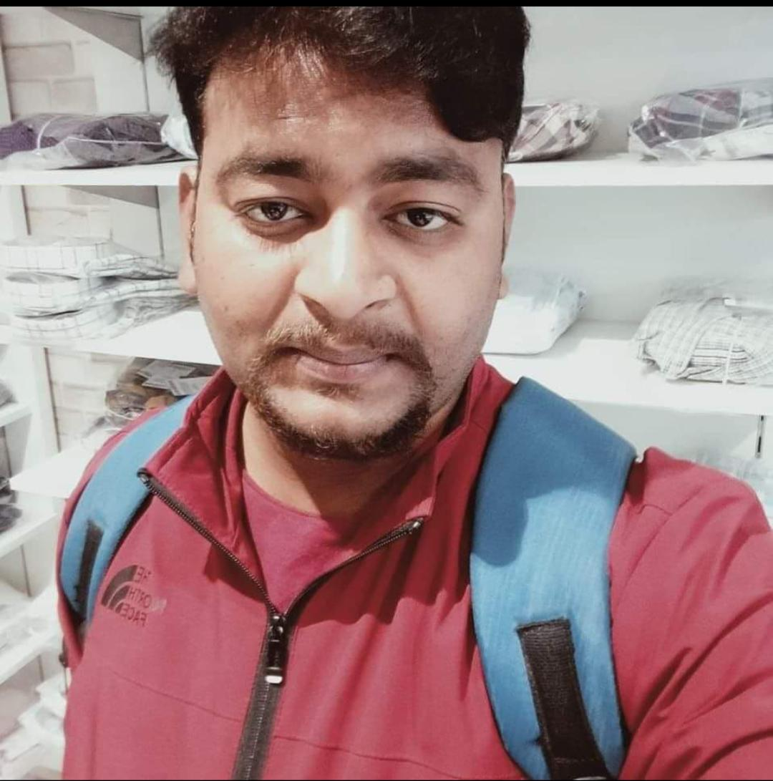
CURRICULUMVITAE

Rishabh Awasthi
Mob- 9621953836
Gmail- unnatiawashi86@gmail.com

ACADEMIC&PROFESSIONALQUALIFICATION :

 | Qualification | School Name | Year of Passing |  | University
1. | B.Sc.(Ag) |  | 2019 |  | University
2. | 12th (Ag) |  | 2015 |  | UP Board Allahabad
3. | 10th |  | 2013 |  | UP Board Allahabad
Other Qualification :

- 2 Months Traning program (sales ) Lakme
- Basic Knowledge in Computer.

Competencies :

- Good Listener & hard worker.
- Belief in relation building & social networking.
- Accepting & delegating responsibilities.
- Flexible in different situations.
- Positive thinking & perception.

OTHERINTERESTS/HOBBIES :

- I always search new ideas to improve my life and my attitude.
- My hobbies are Reading Books and singing songs.

WORK EXPIRENCE

- 7 year Marketing (FMCG)
- One year Paytm on EDC machine
- One year Telecolling

PERSONALDETAILS :

Date of Birth :
Father’s Name : Pardeep Awasthi
Mother’s Name. :
Religion : Hindu
Sex : Male
Nationality : Indian
Marital Status : Married
Language Known : English, Hindi.
Communication Address : 17 para calony near Shubham sweet house Para (226017) Lucknow U.P.
Corresponding Addres : 17 para calony near Shubham sweet house Para (226017) Lucknow U.P.

DECLARATION :

- I hereby declare that the above written particulars are true to the best of my knowledge
and belief.

Date:

Place: (Rishabh Awasthi)

