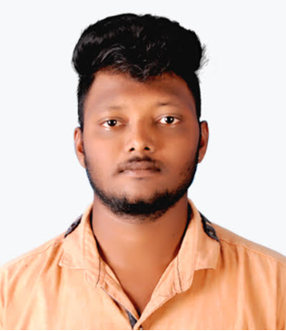

GONTLA SAI CHAITANYA

: gontlasaichaitanya2@gmail.com
: 9985493180

PROFESSIONAL SUMMARY

- Mining Engineering Graduate and Trained Professional in Mining Department

CAREER OBJECTIVE

- Seeking an opportunity which would provide me to enhance in and out my skills and also assure you to contribute my services to take reputed participation in the organizations’ success
ACADEMIC QUALIFICATION

- B.Tech Mining Engg. from Aditya Engg. College, Surampalem, East Godavari Dist., 2020.
- Diploma In Mining Engineering from Loyola Poly., Pulivendula in 2017.
- SSC from The Gelivi’s Venkateswara Vidyalaya, Nandyal in 2014.
EXPEREINCE

- Worked as a TRAINEE 1 Year 2 months 12 days completed at Anand Granite Export Pvt. Ltd., Chimakurthy, Prakasham Dist.
Responsibilities :

- Pit Management
- Pit In-charge
- Blasting Process
- Dumping
- Transportation of Mineral and waste etc.
Worked as a Second class mines manager at RK M sand and aggregates for 2 months
Responsibilities
- Pit Management
- Pit In-charge
- Blasting Process
- Dumping
- Transportation of Mineral and waste etc.

- Worked as a Second Class Mines Manager at Skylark Infra Engineering Pvt.Ltd., for 6 months 6 days.

Responsibilities :

- Pit Management
- Pit In-charge
- Blasting Process
- Dumping
- Transportation of Mineral and waste etc.

ACADEMIC PROJECT

  - I have done a Project on Open Cast Designing and Presentation in my Diploma as a project.

  - Ore body Modelling and Reserve Estimation Technique is the project in final year done by our team regarding how to create a DTM, Block model and Reserve Estimation using SURPAC Software.
INTERPERSONAL SKILLS

- Good interpersonal skills and communication skills
- Positive attitude
- Good planning and passion to succeed
- Smart working
INTERNSHIP

- One month training in Pearls Mine Pvt., Ltd., in Chimakurthy, Prakasham Dist. Andhra Pradesh. Work regarding on the blasting Operation, Transportation of Mineral and Waste, Cutting Process of Granite, Etc…..
SOFTWARE SKILLS

- Packages : MS Office, SURPAC Basis, Auto Cad Basics & Internet Browsing
MINES VISITS

- Granite Mine : Chimakurthy
- Lignite Mine : Tamilnadu (Nyveli Lignite Corporation)
- Dalmia Cement Factory : Chinna Komerla
- Uranium Mine : Pulivendula (Uranium Corporation)
PERSONAL DETAILS

Father’s Name : G.S. Ajay Gandhi
Gender : Male
Date of birth : 26-01-1998
Nationality & Religious : Indian & Hindu
Marital Status : Un-married
Languages known : English, Telugu & Hindi
Address : H.No. 26-603-C1-1
V.C. Colony,
NANDYAL – 518501,
Nandyal Dist., Andhra Pradesh.
DECLARATION

- I sincerely assure that the above mentioned details are accurate to the best of my knowledge and belief.
Date :
Place :
SAI CHAITANYA

