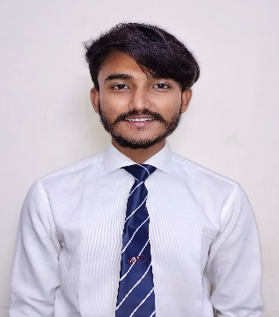




:
Contact Details

KRUNAL PATIL
Date of Birth: 19/04/2001
MALE –23 years

CARRER OBJECTIVE

+91-8154082627
krunalpatil274@gmail.com
PIMPRI, PUNE
https://www.linkedin.com/in/krunal-patil-0690932b2?utm_source=share&utm_campaign=share_via&utm_content=profile&utm_medium=ios_app

Looking for a role where I have a opportunity to discuss my ideas and receive feedback while being mentored towards building my carrier.
Skills / Strength
ACADEMIC DETAILS
STRENGTHS

- Honest
- Problem solver
- Team work
- Multi Tasking
- Working Well under pressure

• PROFESSIONAL SKILLS
- Quick Learner
- Leadership Skills
- Lead Generation
- Good Communication Skills
- Interpersonal Skills
Course | Specialisation | Institute/ College | % CGPA | Year
Master of Science | Organic Chemistry | Dr. D. Y. Patil ACS College, Pune | Pursuing | 2024
Bachelor of Science | Chemistry | SSR ACS College Silvassa | 7.68 | 2022
XII | Science | Veddant Multipurpose School Valsad, Gujarat | 60.40 | 2019
X | __ | Shett R.J.J High School Valsad, Gujarat | 81.62 | 2016

CERTIFICATIONS COURCE

- Basic (Excel, M.S. Word, Power Point)
- CCC
- Google
- Technology Based Entrepreneurship Development Program (TEDP)
- Artificial Intelligence

Languages Known
- English
- Hindi
- Gujarati
- Marathi

ACHIEVEMENTS & POSITIONS OF RESPONSIBILITY
HOBBIES
I selected at National Service Scheme Unit for Video Making &
- Cricket
- Travelling
- Acting
- Photography

Social Issues & their Solution.
DECLARATION
Sai Darshan Apt.: 1 Near
BAPS School Dharanagar Abrama
Valsad, Gujarat 396002
Contact Number: 8154082627

I hereby affirm that all the above furnished details are knowledge.

