
EDUCATION

Bachelor of Science in Artificial Intelligence and Machine Learning | Chandigarh Group of Colleges, Landan
Session: 2022-2025 | Score: 8.75 CGPA
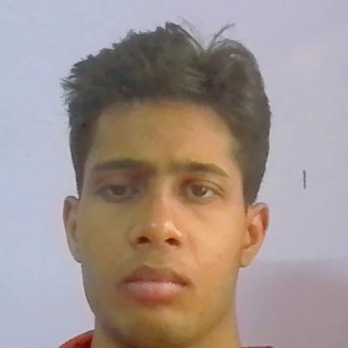

Paste Your Photograph Here
Intermediate (CBSE) | Kendriya Vidyalaya Sector-29A, Chandigarh
Session: 2021-2022 | Percentage: 60%

Harshit Chand
Matriculation (CBSE) | Saint Soldier International School, Chandigarh
Session: 2019-2020 | Percentage: 73%

TRAINING & PROJECTS

#418A Sector-29A, Chandigarh ,160030
7652812581
harshitchand37@gmail.com
LinkedIn

PROFESSIONAL SUMMARY

A well-organized, creative and goal-oriented under-graduate possessing excellent problem-solving and skills with a flair to explore suitable avenues in Machine Learning & Data Science while developing advanced projects with efficiency and quality.

TECHNICAL COMPETENCIES

OS: Windows
Languages: |R | Python | HTML | JavaScript
Databases: MySQL, PowerBI
Other Interests: Cloud Computing

INTERPERSONAL SKILLS

| Management & Coordination
| Decision Making & Analytical Skills |

INTERESTS & HOBBIES

Gaming | Watching Football| Cricket

LANGUAGES KNOWN

English | Hindi

PERSONAL DETAILS

Mother’s Name: Pinki
Father’s Name: Satish Chand
D.O.B: 15 February 2005

Minor Projects:

Dibetes Prediction Using Machine Learning

Guess My Number Using HTML CSS and JavaScript

Major Projects:

House price prediction with machine learning + deployment on flask

CERTIFICATIONS

- SQL Problem Solving (Intermediate)
- Problem Solving

