CURRICULUM VITAE  ADITYA GURUNG  CONTACT NO.: 8597727634(W.APP)  EMAIL I.D : adityagurung310@gmail.com | 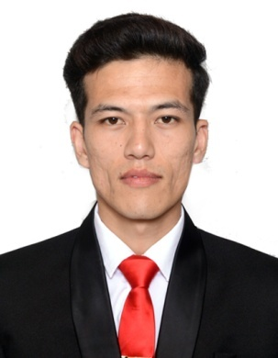

CAREER OBJECTIVE:

Secure a responsible career opportunity to fully utilize my training and skills, while making a significant contribution to the success of the company.

PERSONAL INFORMATION:

FATHER’S NAME | : | ROHAN GURUNG
MOTHER’S NAME | : | ARATI RAI
DATE OF BIRTH | : | 28TH NOV, 2000
NATIONALITY | : | INDIAN
SEX | : | MALE
MARITAL STATUS | : | UNMARRIED
QUALIFICATION | : | GRADUATION APPEARING
PRESENT ADDRESS | : | RABINDRA NAGAR,  NEAR RABINDRA SANGHA CLUB  P.O – RABINDRA SARANI  P.S- SILIGURI  DIST – DARJEELING  PIN- 734006
PERMANENT ADDRESS | : | UPPER RABEK, RISHAP  LAVA, KALIMPONG  P.O- LAVA  P.S- KALIMPONG  DIST. – KALIMPONG  WEST BENGAL  PIN.- 734319

ACADEMIC QUALIFICATION:
SN | EXAMINATION | BOARD | YEAR
1 | MADHYAMIK | W.B.B.S.E | 2019
2. | HIGHER SECONDARY | W.B.C.H.S.E | 2021
3. | BBA IN TOURISM, AVIATION & HOSPITALITY | N.B.U | APPEARING

ACHIEVEMENTS
- REPRESENT AS THE CAPTAIN OF THE SCHOOL FOOTBALL TEAM.
- AWARDED AS "MR FRESHER " RUNNERS UP.
- REPRESENT SCHOOL HEAD BOY (2020-2021)
EXTRACT CULLICURAL ACTIVITY

- PLAYED FOOTBALL IN DIFFERENT LEVELS .
- PARTICIPATE IN MANY SOCIAL WORK.
- PARTICIPATE IN MANY EVENT ORGANIZED BY SILIGURI COLLEGE.

LANGUAGE KNOWN

LANGUAGE | ENGLISH | NEPALI | HINDI
SPEAK
READ
WRITE
HOBBIES

- DANCING
- MUSIC
- FOOTBALL
SKILLS

- GOOD COMMUNICATION
- LEADERSHIP SKILLS
- TEAM WORK
- INTERPERSONAL
DECLARATION:

I DO HERE BY DECLARE THAT ALL STATEMENTS STATED ABOVE ARE CORRECT TO THE BEST OF MY KNOWLEDGE AND BELIEF.

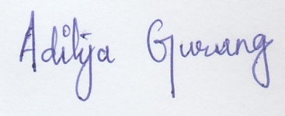

DATE:
PLACE:

SIGNATURE

