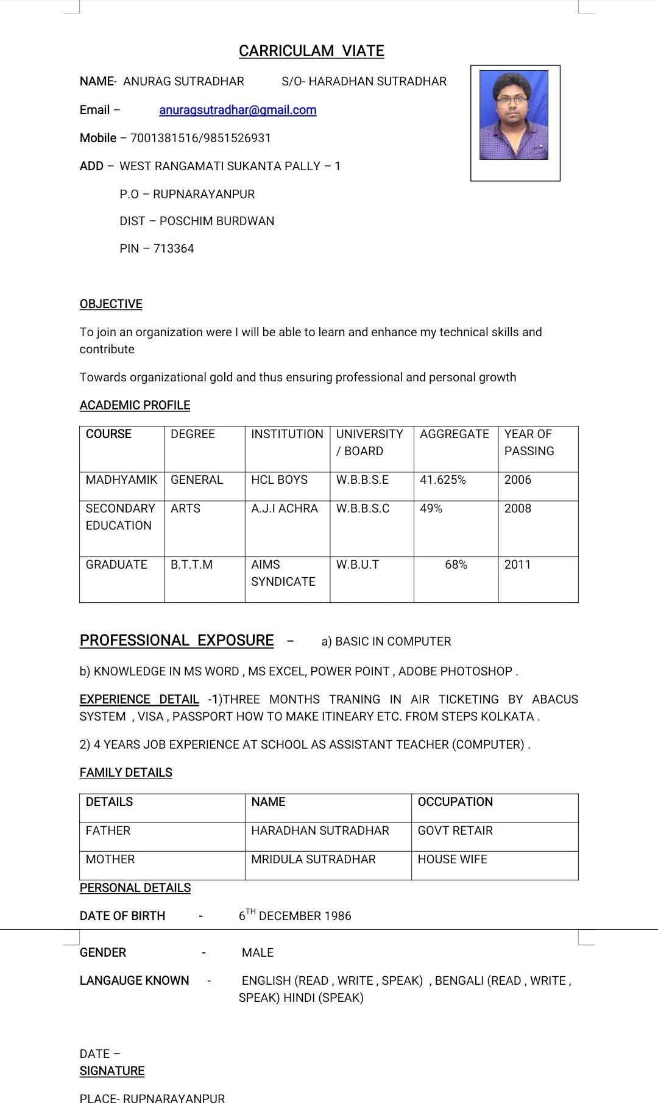
3) RUNNING JOB AT SM HERO 1ST AS PARTS INCHARGE NOW AS A FRONT LINE SUPERVISOR FROM 1 YEAR.

