PRAVIN RP

Mobile: 91-8610463151
E-Mail: pravinpalanivel@gmail.com
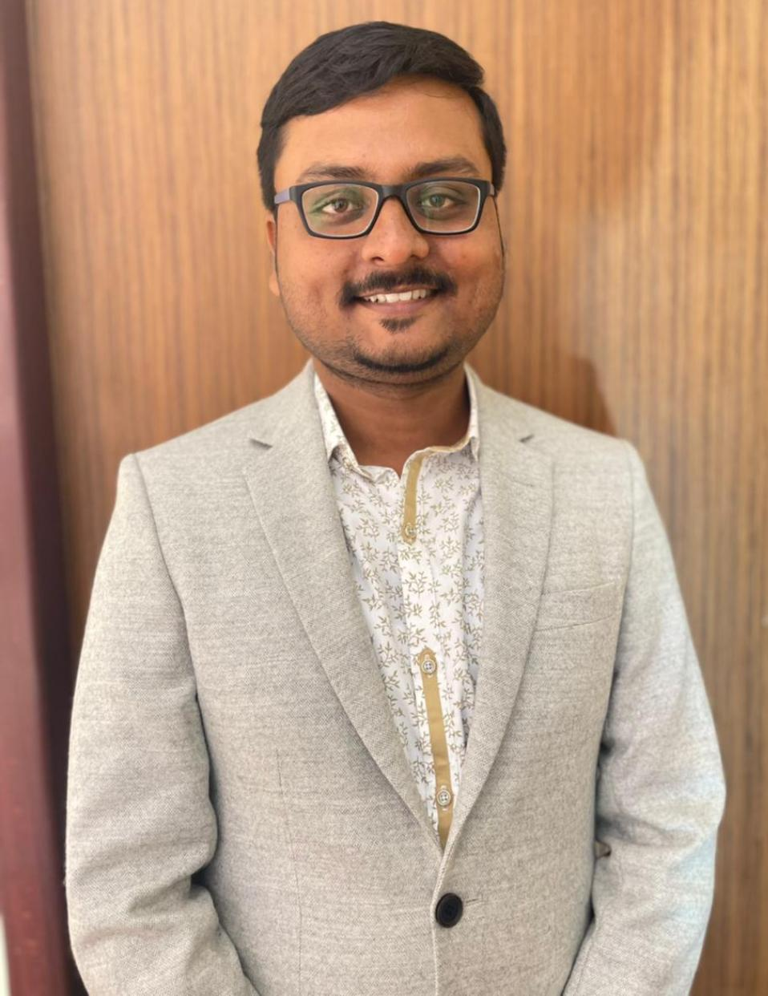  STRENGTHS  - Flexible and can adapt quickly to new working environment  - Eager to learn new things from others  - Ability to work independently and as a part of a team | ACADEMIC QUALIFICATIONS:  - B.E (Computer Science and Engineering) at Karpagam  Institute of Technology, Coimbatore, Tamil Nadu.  CGPA : 6.51 Completed :2020  - HSC at SRV Boys Higher Secondary School, Rasipuram, Tamil Nadu.  Percentage: 84% Completed : 2012  - SSLC at Vetri Vikaas Matric Higher Secondary School, Rasipuram, Tamil Nadu.  Percentage:88.8% Completed : 2010  INTEREST:  - Photography  - Playing chess  - Exploring about Cars  - Travelling  TRAINING & CERTIFICATION:  - Completed Business English Certification at Vantage Level(2014).  - Completed Campus Connect Program Conducted by Infosys(2015).  - Participated in "PROJECT EXPO" at Karpagam Institute of Technology, Coimbatore(2013).
I am looking for a position wherein I can utilize my skills and also passionately grow and contribute goodness in the most effective manner by being a key with unlimited loyalty and commitment.
PERSONAL PROFILE:  Linkedin  Passport no : N9964952  Date of issue : 06-09-2016  Date of Expiry : 05-09-2026  Date of Birth : 17-05-1994  Sex : Male  Marital Status : Single  Nationality : Indian  Linguistic Skills: English, Tamil, Hindi | WORK EXPERIENCE:  - 1.5 years of Experience in working as Assistant Manager at 5k Car Care  As an Assistant manager at 5k Car Care I’m primarily responsible for the overall operations and management of a single branch, including customer service, staff supervision, sales, ensuring quality car detailing services are delivered, and meeting sales targets within their designated location, essentially acting as the primary point of contact for customers and staff at that branch.  - 1.5 years of Experience in working as Operations Manager at Anok and Co  As an Operations Manager at Anok and Co I’m responsible for day to day operations of business which includes oversee operations of all departments, optimize the process, manage resources, ensuring quality control, developing strategies, leading the team and making final decisions.  DECLARATION:  I,PRAVIN RP , hereby declare that all the information mentioned above is true to the best of my knowledge and belief.  Pravin RP

