ajayantonyajayantony03@gmail.comAJAY ANTONY.V

+91 88388 90205

1/33 3rd Street shippoy nagar

Kumannanchavadi poonamalle

P R O F I L E
I am a Energetic college student poised for the profes sional realm, I bring a positive mindset, swift problem-solving skill s, and a keen ear for effective communication and confidentiality. Ready any work environment, I am committed to delivet_{o}ri ng sol utions with a proactive and attentive approach. Collaborating with other departments and being a team player helps HR int egrate effectively into the overall organisational structure . I am a ble to work well both in a team environment as well as using own initiative.

E X P E R I E N C E
. internship
. worked as a record keeper at hospital.
. worked as sales and management ,date entry and completing problem of online client.

STRENGHT
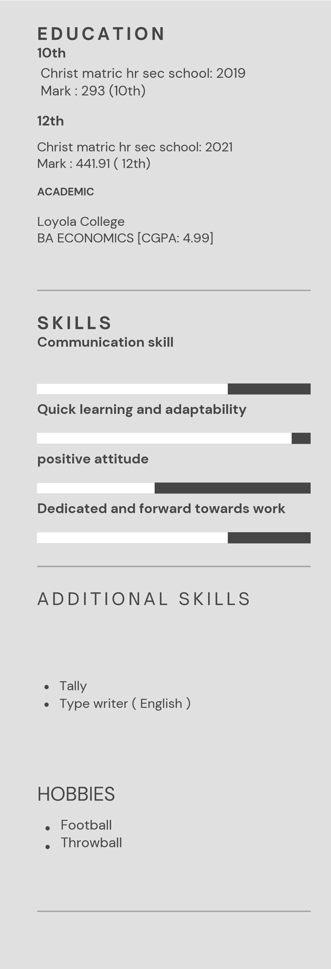
C
Quick learner problem solver Good at team work
Organisational skills
Greater flexibility
Adaptability
Innovative skills
Good at decision making

Languages known:
English
Tamil

Declaration

I hereby declare that the information provided in this resu me is true and accurate to the best of my knowledge.

