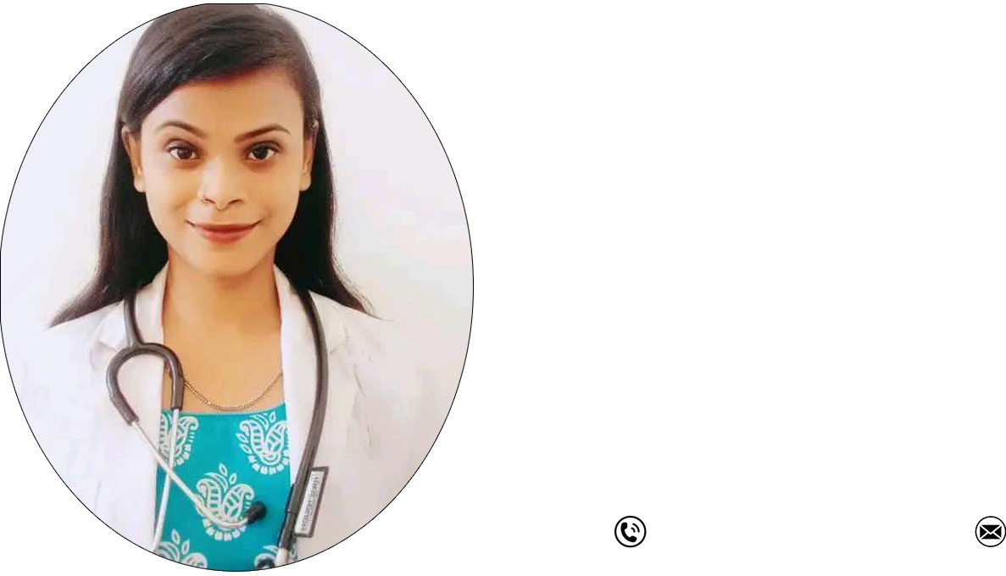




DR. ANUSMITA TALUKDAR
Physiotherapist
Attentive physiotherapist with 2 years of experience, who is willing to provide a high level of expertise and a solid work ethic to the patients. Committed to enhancing patient’s quality of life through compassionate care and instruction, Seeking a position as a physical therapist where I can demonstrate my sound clinical judgment in treating patients and keeping track of their progress.
6000609170
Email id-dranusmitatalukdar15@gmail.com
ACADEMIC PROJECT
CERTIFICATION
WORK EXPERIENCE



Bachelor of physiotherapy from Regional college of paramedical and health sciences Physiotherapy which is
ACADEMICS
PERSONAL STRENGTH
affiliated to srimanta sankardev university

Underwent training in an internship at Guwahati medical college and Hospital

“Rehabilitation of GAIT and Step training in Parkinson's Disease to reduce Fall” Therapeutic Ultrasound Electrical Stimulation Ergometer Testing Heat and Cold Therapy Yoga and Pilates
Strength Training Sports Massage

All Assam Physiotherapy Association as a Life Member,
Reg.AAPA/0374/23



6 months of Internship at Guwahati medical college and hospital from 1 December 2022 to 17 july 2023
INTERNSHIP
LANGUAGE

Assamese Hindi English

Possess strong interpersonal skills to connect well with patients.

Has sensitivity, tact, tolerance, and patience.

Familiarity with cutting-edge medical technology and tools.

Expertise in a wide variety of methods for enhancing physical performance, regaining mobility, and building muscle.

Fluency in several modalities, including manual, electrical, and exercise therapies.

Working as a Physiotherapist at N.k physiotherapy clinic and rehabilitation centre and life line physiotherapy clinic and sports rehabilitation centre Therapy august 2023 to Till date.

Determined whether physiotherapy interventions required by evaluating patients.

Assessed patients in accordance with the standards and guidelines for professional practice

Treated individuals with movement disorders that they have had since birth or that they have acquired because of an injury.

Examined the patient's development on a regular basis for indications of lessened stiffness, pain, and discomfort. Introduced patients to new tools and equipment that will help them with regular exercise

Analyzed the results of therapy and share the patients' development Kept a record of all patient care services.
Worked together with other team members to provide comprehensive care

