S/o: Mohammad Tajuddin , H.No:1-1-122 Noor Nagar, Ramagundam ,
Peddapalli District, Email Id: tajjushah7@gmail.com
Telangana State Contact: +91- 8187035277

To obtain a challenging position in creative and rewarding environment, where I can learn new things, commit myself and make best utilization of my skills and abilities in the work entrusted.

Intermediat e  (CEC) | Tagore Junior College, Maripeda | Board of Intermediate Education | 2017 | 68%
SSC | Subodh School, Ramagundam | Board of Secondary Education | 2015 | 50%

- Worked as a Airtel Promoter, Maripeda, Mahabubad District for a period of one (1) year.
Worked As A (Group creditofficer ) In SMFG INDIA CREDIT For A Period Of one (1) Year

Present Working In saarathi finance Credit Frivate Limited As A
Relation ship Manager since (May 2025)

- Willingness to learn new tasks.
- Able to work under pressure
- Able to complete challenging tasks.
- Highly efficient & energetic to perform any kind of work.

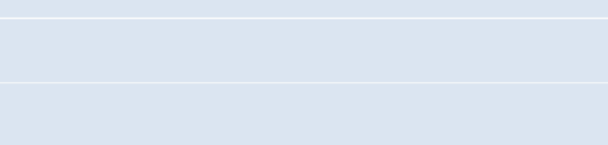

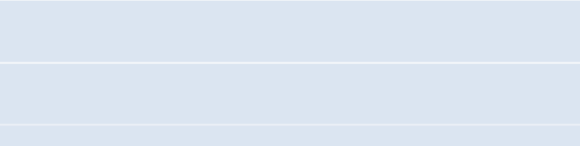
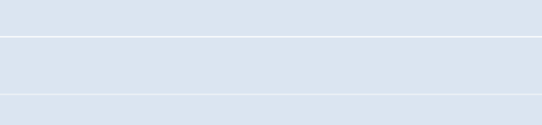
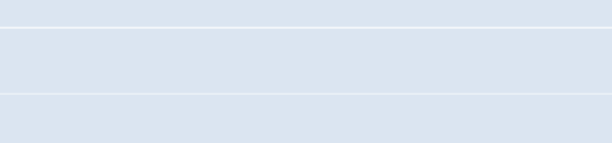
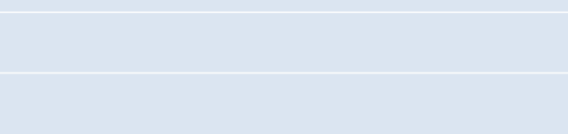
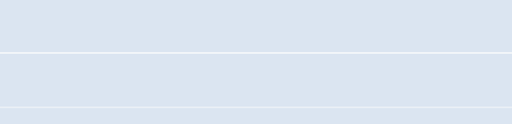
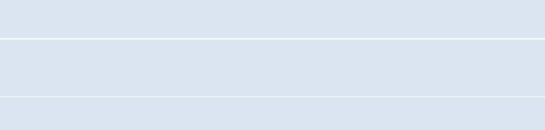
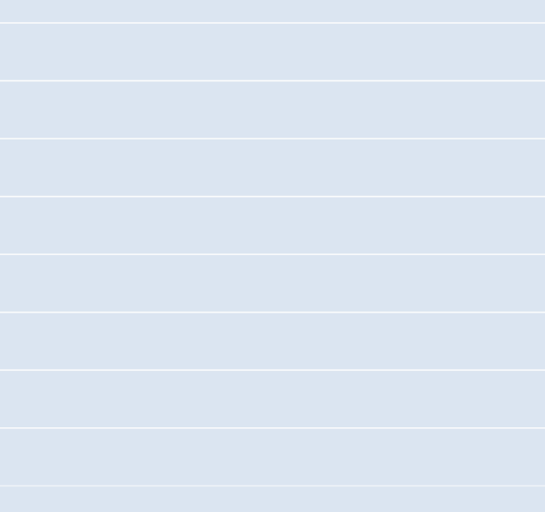
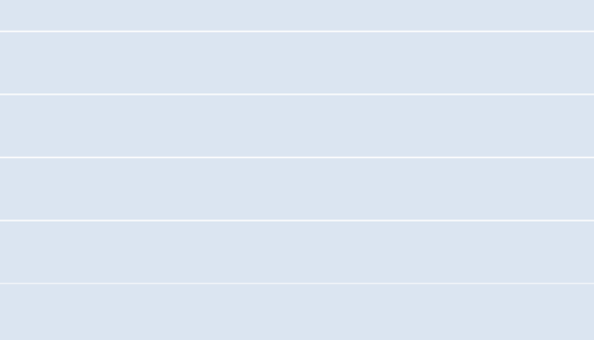
MOHAMMAD PARVEZ AKBAR
 | Mohammad Tajuddin
 | 01-07-1998
 | Male
 | Married
 | English, Hindi, Urdu & Telugu
 | Indian
 | H.No: 1-1-122 Noor Nagar, Ramagundam , Peddapalli District, Telangana State.
 | +91- 8187035277

:

I hereby declare that the above furnished information is true to the
bestof my knowledge and belief.

Date :
Place : Warangal

(MOHAMMAD PARVEZ AKBAR)

