Prernashah
Address:vijaynagar,Indore(M.P.)
prishita7414@gmail.com
+918058237414
https://www.linkedin.com/in/prerna-shah-b6983b231

CAREER OBJECTIVE:
Seeking a challenging role where I can utilize my knowledge , programming skills, and passion for technology to contribute to innovative projects and further enhance my expertise in the field.

ACADEMIC RECORD:
- Currently pursuing Master of computer application with
7.70 CGPA from Acropolis Institute of technology and Research , Indore(M.P.)
- Bachelor of Computer Application : 78.1 % from Mandsaur University (M.P.)
- Higher Secondary (12th CBSE) : 75% from St. paul’s sr. secondary school Pratapgarh (Raj.)
- Senior Secondary (10thCBSE) : 78% St. paul’s sr. secondary school Pratapgarh (Raj.)

PROJECTS:
  - Food Mart : Ecommerce website
Contains two panels- Admin panel and User panel .
Technologies Used :
Frontend : HTML,CSS,JAVASCRIPT
Backend : PHP,MYSQL

CERTIFICATE:

NPTEL certification
Problem solving through programming in C.
- Coursera certification
Introduction to python

CO-CURRICULARACTIVITIES:
- Participated in 36-hour long hackathon “KRIYETA”.
- Participated in Walkathon/Cycle Treasure Hunt Organized by Ekal Yuva Indore.

Reference: Prof. Geeta Santhosh, HOD of Faculty of Computer Application department at Acropolis Group of Institutes.
hodfca@acropolis.in
+919884291264
Declaration : I here by declare that the information above is true to best of my knowledge.


Place : Indore

Date :
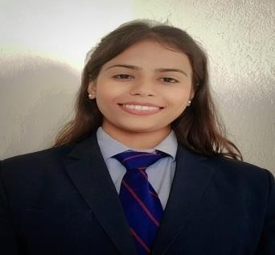

TECHNICALSKILLS:

Frontend:
- Html , css , java script
Backend
- PHP
- MySQL
Programming language
- C
- Python

STRENGTHS
- Patience
- Communication

AREAOFIMPROVEMENT:
- Multitasking

PART OF INTEREST:
- Dancing

PERSONALDETAILS:
Date of Birth : 16-10-2001 Gender : Female Marital Status : Unmarried Nationality : Indian Mother Tongue : Hindi Languages Known :Hindi , English
Father’s Name :Mr. Shreepal shah
Permanent Add. :Sadar bazaar , mahal darwaza pratapgarh (raj).

Prerna shah

