RESUME
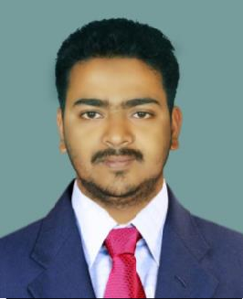
SURESH KUMAR BISWAL
C/o- Nimain Charan Biswal
Qtr No- 1B/36
At/Po- South Balanda
Ps- Colliery Dist- Angul Pin- 759116
State- Odisha
Contact No- +91-9437440676
Email id- sureshbiswal571@gmail.com

CAREER OBJECTIVE
Looking for a challenging career which demand the best of my professional ability in terms of technical & analytical skills & helps me enhancing my current skills & knowledge. To reach top of the Success in professional field.

EDUCATIONAL QUALIFICATION

Name of Exam | Name of the Institution | Board/University | Year of passing |  | Percentage /CGPA
10th | DAV Public School, Jagannath Area MCL, Talcher, Angul | CBSE | 2010 |  | 5.4
Diploma (Electrical) | Adarsha School of Engg & IP, Angul | SCTE & VT | 2015 |  | 70.8%
B.Tech (Electrical) | Adarsha College of Engg, Angul | BPUT Odisha | 2019 | 76.10%

COMPUTER SKILL

PGDCA

PERSONAL QUALITIES

- Highly motivated and eager to learn things.
- Strong motivational and leadership skills.
- Ability to produce best result in pressure situation.
- Excellent communication skills in written and verbal both.
- Ability to work as individual as well as group.

PERSONAL DETAILS
Father’s Name : Nimain Charan Biswal Mother’s Name : Gouri Prava Biswal Date of Birth : 20th Jan 1995
Nationality : Indian
Marital Status : Unmarried
Sex : Male
Religion : Hindu
Languages Known : Odia, Hindi and English
Experience : No

DECLARATION
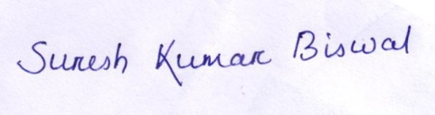
I hereby declare that above mentioned information is correct to the best of my knowledge and I bear the responsibility for the correctness of these particulars.

Signature of Candidate

