OBJECTIVE

Sarda Bhakti Badrinarayan

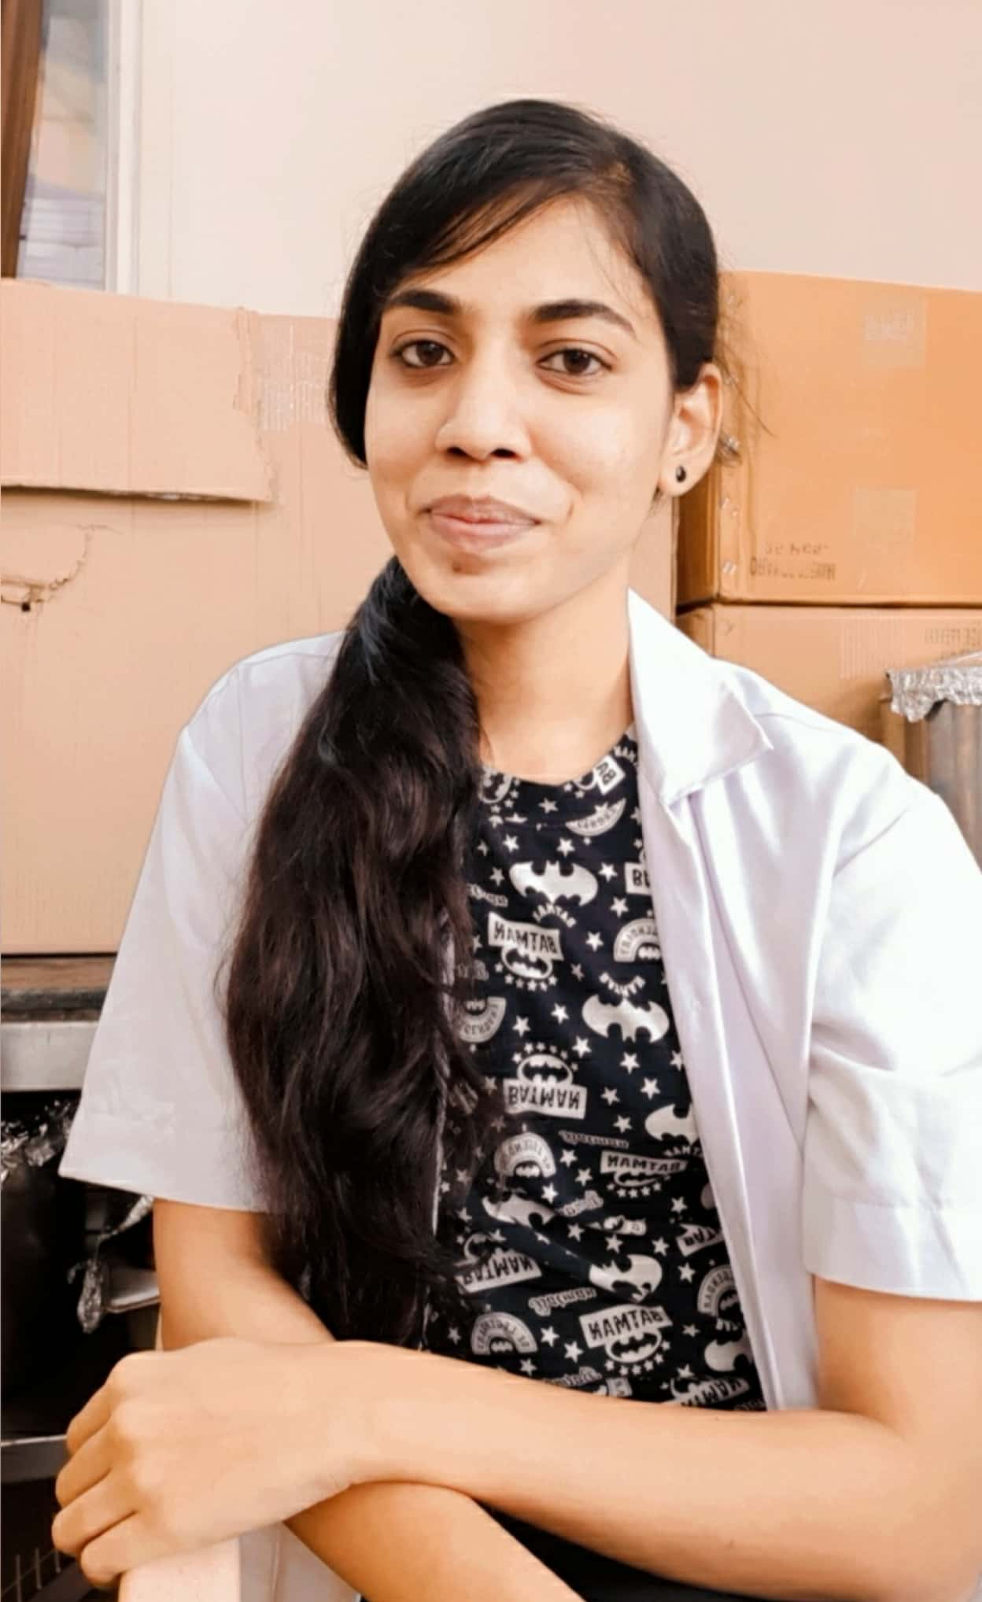
PHONE : 9767060387
EMAIL ID : bhaktibsarda234@gmail.com
Instagram page: @nutritionist_bhakti
PERSONAL DETAILS
>DATE OF BIRTH: 21/03/1999
>GENDER: FEMALE
>ADDRESS: KHANDOBANAGR, SHEVGAON, TAL. SHEVGAON, DIST. AHMEDNAGAR
>NATIONALITY: INDIAN
>MARITAL STATUS: UNMARRIED
>LANGUAGE KNOWN: MARATHI, HINDI, ENGLISH AND MARWADI
PERSONAL STRENGHTS
>PERSONALITY
>COMMUNICATION SKILLS
>PUNCTUALITY
>HARDWORKING
>RESPONSIBLE
>LEADERSHIP
>LOYALTY

Looking for a suitable position that enables me to utilize my education in the field of Food Science and Nutrition as an individual or a member of a team
WORK EXPERIENCE
- Internship at KOKILABEN DHIRUBHAI AMBANI HOSPITAL, MUMBAI (Nov-Dec 2018)
- Case Studies on Gastroenteritis and Renal Disease. (Nov-Dec 2018)
- Work Experience at Ayur Diabapro Diabetes Clinic, Pune (April 2019 - July2019)
- Working as Clinical Dietitian at DR. D Y PATIL HOSPITAL, Pune (Jan 2020 – Present)
EDUCATION
- B.Sc. in Home Science with Specialization in Food Science And Nutrition, Pune University (2016-2019)
- Certificate in Food and Nutrition, IGNOU University
- Certificate in Weight Management: Beyond Balancing Calories (Coursera)
- Certificate in Nutrition and Lifestyle in Pregnancy (Coursera)
- Balasaheb Bharde High School, Shevgaon, Tal. Shevgaon, Dist. Ahmednagar (2013-2014), State Board
- Higher Secondary in Balasheb Bharde High School, Shevgaon, Tal. Shevgaon, Dist. Ahmednagar (2015-2016)

EXTRA CURRICULAR HAPPENINGS
- Savitribai Phule Pune University Zonal Level Research Project Competition Avishkar (2016)
- Women’s College of Home Science and BCA, Loni , Ahemednagar NACC Sponsored National Seminar “Integrating ICT for Quality Improvement in Higher Education (2016)
- District Level NSS camp sponsored by Sangamner college - 2017
- A workshop conducted by Department of Lifelong and Extension , Savitribai Phule University, Pune on the topic “ Entrepreneurship Development” in Women’s College of Home science and BCA ,Loni, Ahemednagar(2019)
- A workshop conducted by Student Development Department, Savitribai Phule University, Pune on the topic “Intellectual property Rights” in Women’s College of Home science and BCA, Loni, Ahemednagar(2019)

Declaration : I here by declare that to the best of my knowledge the above said information is true.

