RESUME

Career Objective:
Be a part of a reputed organization in a responsible and challenging position me the scope to harness my skills and strengths in the field of Façade Site Manager
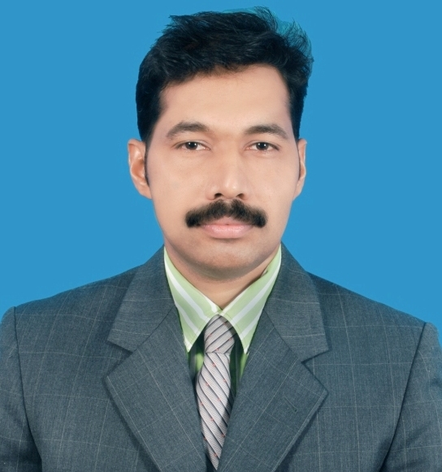  SUNIL KUMAR.S  s.sunilpillai@yahoo.com  Mob +91 6238083093 ( INDIA )  Mob + 91 8547223093. ( INDIA )  Date of Birth:  10 -05 -1977  Gender:  Male  Marital Status:  Married  Languages:  English, Malayalam ,Hindi ,Arabic  Permanent Address:  Sunil Kumar.s  Suresh Bhavan  Mannam Nager (po)  Perumpulickal , Pandalam  ,  Pathanamthitta (Dist)  ,Pincode-689501  Kerala , INDIA.  Passport Details :  Passport No : M 3969394  Place of Issue : DOHA QATAR  Date of Issue : 19 – 02 - 2015  Date of Expiry : 18 – 02 - 2025  Driving license Details :(INDIA)  License No :  Place of Issue : KERALA  Date of Issue :  Date of Expiry :  PROFESSION  Project Manager  NATIONALITY  Indian  MEMBERSHIP  COMPUTER SKILLS  Microsoft Office  Word  Excel  Power point  Auto CAD  Auto plotter | Academic Qualification : Civil Engineering from Kerala Technical Board, Kerala, India, 1997  Pre-Degree from Kerala University India, 1994  Technical Qualification – ATO CAD , Windows 98/2000/XP/Vista  Word, Excel & Power Point , Int. Explorer, Outlook  Professional Experience : UP TO 23 YEARS EXPERIENCE INCLUDING  UP TO 20 YEARS IN GCC  Professional Knowledge  - Manage and supervise the execution of the project.  - Coordination with Contractor and Sub-Contractor for execution of the project.  - Technical correspondence with Client, Consultant and Subcontractors.  - Planning and scheduling the activities on daily, weekly and monthly basis.  - Managing the shop drawings, Material Submittals, Document Submittal, Sub-Contractor approval etc.  - Well knowledge about IR, MIR and NCR.  - Progress monitoring during the execution of work and preparation of weekly and monthly progress report.  - Self-handling the project from the date of demarcation to hand over the project within the target.  - Handling the Multination work force and good coordination with Contractor.  - Coordination with consultants for checking and approval of works.  - Attended all inspection of all structural elements in accordance to shop drawings and consultants approval on site.  - Full coordination of works directly to the  - Taking full care for the safety of workers at site and make sure that work is carried out in safe condition.  - Assures a valid Project Safety plan is in place.  - Proactively promotes Health & Safety considerations throughout the project, as well as to project partners especially at site.  - Promotes healthy work-life balance within the project team at site.  - Assures safe transportation of the reporting employee and subcontractors as per HSE plan.  - Instructs newly arrived site team on safety guidelines for working on site project.  - Keeps an updated site log book recording site work.  Career Profile  Site Manager - M/S AL Ghurair Construction Aluminum ( U A E )  Senior project engineer - M/s ALU-NASA Salam International WLL.,(QATAR).  Project engineer - M/s. Verity Structural L.L.C, (UAE,)  Project Installation engineer - M/s. Danway Industries L.L.C ( Abu Dhabi,  UAE )  Project engineer - M/s. Aluminum Services (Manama, Bahrain).  Project supervisor - M/s. ALU-TEC WLL ( Doha, Qatar ).  Site supervisor - M/s Shabak Engineering (Mumbai, India )  HANDLED PROJECT  Duration : 2017 Aug To May 2020 - M/s AL Ghurair Construction Alu (UAE)  - Project - Sky View UAE  Client - EMAAR Properties  Duration : 2010 To Aug 2017 M/s. Alu Nasa W.L.L, Doha-Qatar  - Projects - Lusail Multipurpose Hall, Doha  Client - M/s Astad project management, Qatar Olympic (QOC)  - Projects - Msheireb Downtown , Doha  Client - M/s Msheireb Properties , Doha  - Projects - World Trade Centre, Cornice, Doha, Qatar  Client - M/s Qatar General Insurance & Reinsurance Company  - Projects - Jaidah Commercial Development Building , Doha  Client - M/s Jaidah Investment and Real Estate Development Co  Job Description  - Tension Rod system, Glass roof system ,Spider system, Unitized system ,Stick system, Aluminum cladding ,Window Door system and any tip Aluminum Glass ,steel installation  - Reporting to Project Manager & Managing Director  - Overall In charge of Site Activities  - Scheduling & Sequencing installation  - Managing & Controlling a Multination work force.  - Preparation of man-hours to evaluate the end result of the project at the completion stage & reporting to the management.  - Following up purchase department for materials.  - Raw material intending to site installation manager.  - Promotes healthy work-life balance within the project team at site  Duration: 2009 to 2010 M/s. Verity Structural L.L.C, Dubai, UAE  - Project - Dubai Metro Dubai , UAE  Client - Dubai Roads and Transport Authority  - Project - Rocco Forte Hotel in Abu Dhabi , UAE  Client - M/s TDIC and AL Farida Investments Company  Job Description  - Tension Rod system, Spider system, Unitized system Tension cable system ,Space frame system  - Reporting to Project Manager & Managing Director  - Overall In charge of Site Activities  - Scheduling & Sequencing installation  - Managing & Controlling a Multination work force.  - Preparation of man-hours to evaluate the end result of the project at the completion stage & reporting to the management.  - Following up purchase department for materials.  - Raw material intending to site installation manager.  - Promotes healthy work-life balance within the project team at site  Duration : 2008 to 2009 M/s. Danway Industries L.L.C, Abu Dhabi,UAE  - Project - AL JAZEERA Stadium – Abu Dhabi ,UAE  Client - Al- Jazira Sports Club  Job Description  - Steel Hanging Bracket, Aluminum Cladding and Design glass  System , Speciality system  - Reporting to Project Manager & Managing Director  - Overall In charge of Site Activities  - Scheduling & Sequencing installation  - Managing & Controlling a Multination work force.  - Preparation of man-hours to evaluate the end result of the project at the completion stage & reporting to the management.  - Following up purchase department for materials  - Assures a valid Project Safety plan is in place.  Duration : 2006 to 2008 M/s Aluminum Services, Manama , Bahrain  - Project – Seef Mall , Manama, Bahrain  Client - Seef properties BSC  - Project - LMRA –Support Center ,Manama ,Bahrain  Client - Labour Market Regulatory Authority  Job Description  - Spider fin glass , Stick curtain wall , Aluminum cladding system, Glass roof system  - Reporting to Project Manager & Managing Director  - Overall In charge of Site Activities  - Scheduling & Sequencing installation  - Managing & Controlling a Multination work force.  - Preparation of man-hours to evaluate the end result of the project at the completion stage & reporting to the management.  - Following up purchase department for materials.  - Raw material intending to site installation manager.  - Assures a valid Project Safety plan is in place..  Duration : 2000 to 2006 M/s. ALUTEC W.L.L Doha, Qatar  - Project - Khalifa Stadium , Women’s Club , Doha Qatar Client - Khalifa sports city Doha ,Qatar  - Project - Al Jazeera T.V Channel  Client - Qatar foundation  - Project - H.S.B.C Tower ,Doha , Qatar  Client - United consultant  - Project - Mahmood Tower Doha Qatar  - Project - Fizel Tower , Doha , Qatar  Job Description  - Point Support Glass System ,Curtain wall & Cladding System  Glass Roof System ,Door Window System ,Etc  - Reporting to Project Manager.  - Overall In charge of Site Activities  - Scheduling & Sequencing installation  - Managing & Controlling a Multination work force.  - Assures a valid Project Safety plan is in place  Duration : 1997 – 2000 Shabak Engineering Consultants, Mumbai, India  (Engineering Consultants for Multi Story Buildings)  Site Supervisor  Job Description  - Point Support Glass System ,Curtain wall & Cladding System  Declaration:  I hereby declare that the details furnished above are true to the best of my knowledge. The necessary and supporting documents shall be submitted as and when needed.  Expected salary  Place: KERALA INDIA Yours Faithfully,  Date : 4. 09 . 2021  (Sunil Kumar .S)  (+91 6238083093 , 8547223093 )

