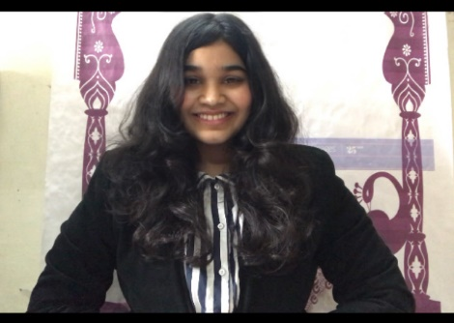
APURVA HANSRAJ KALE
PROJECT:
NCRA TIFR, PUNE;
Design of 3.2m Antenna to withstand wind load of 40-80kmph, structural analysis and manufacturing
Research Paper : https://www.ijser.org/onlineResearchPaperViewer.aspx?Paper-on-Wind-Load-Estimation-and-Truss-Optimization-of-Parabolic-Radio-Dish-Antenna.pdf

WORK EXPERIENCE :
TopRankers Edtech : Digital marketing intern
COLLEGE MEDIA TEAM: DRAFTING, CONTENT WRITING, VIDEOGRAPHY, ANCHORING, MANAGING THE SOCIAL MEDIA ACCOUNT OF COLLEGE AND OTHER SUB-TEAMS OF COLLEGE, HELPING THE MARKETING HEAD OF AISSMS INSTITUTE FOR PUBLICITY, WRITING THE FLIER CONTENT.
ACADEMIC DETAILS:
SSC | Dr. Kalmadi shamrao high school | SSC | 2005-2015 | 84.64
HSC | Laxman rao apte prashala | HSC | 2015-2017 | 55.02
GRADUATION | AISSMS , COE | Affiliated with SPPU | 2017-2021 | 7.61 CGPA

- CAREER OBJECTIVE : To work at an entry-level position at a reputed organisation to gain immense exposure as well as expand my knowledge and skillset while also ensuring that organisations goals are accomplished.

Computer Skills:
Operating Systems: Windows, DOS
Packages Known: MS Office (Word, PowerPoint, Excel)
Software Known: C, C++, CATIA, SOLIDWORKS, Auto-Cad

ADDRESS: C6, NCRA TIFR, TYPE 3C, KHADKI AUNDH ROAD, OPPOSITE TO IUCAA, PUNE-07
phone number: 9637001059
EMAIL ID: apurvakale4799@gmail.com

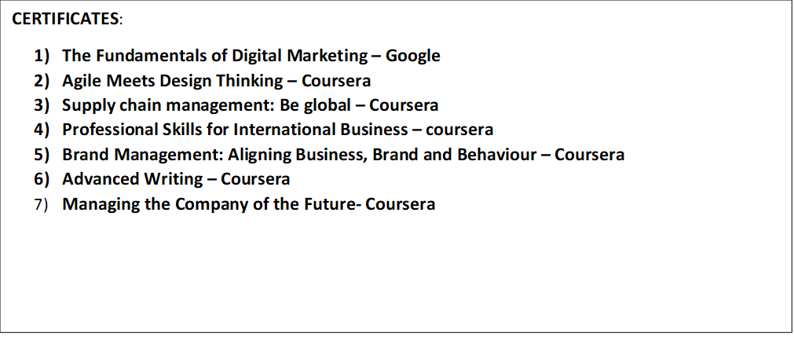
DECLARATION: I hereby declare that the details furnished above are true and correct to the best of my knowledge and belief and I undertake to inform you of any changes therein, immediately.
Place: Pune
Date:19/05/2021
PERSONAL DETAILS:
Date of Birth: 30/04/1999
MARITIAL STATUS: Single
Strengths:
• Excellent interpersonal Skills
• Good with communication skills
• Good with building connections (ice-breaking sessions)
• A team player with leadership qualities.
• Disciplined
• Highly Diligent and Committed towards work.
• Honest, Determined and Focused

Languages: English, Japanese, Hindi and Marathi

