CURRICULUMVITAE

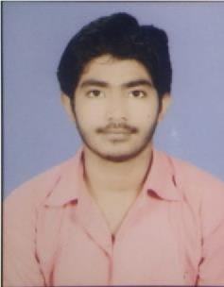
SIDHARTHA SOUMYA MISHRA
At-BENTAL
Po - AHARPADA Via-GUJIDARADA
Dist.- BHADRAK (ODISHA)
Pin-756128

Contact Number: +919861525240 E-mail-sidharthasoumya.mishra98@gmail.com

Objective

I am looking forward to have an opportunity to work for an organization andinstitution to my fullest potential and ability and thereby contributing to the growth of theorganization.

ACADEMICQUALIFICATIONS

Course | Board /University | YearofPassing | % | DIV
10th | B.S.E(ODISHA) | 2014 | 63.16% | 1ST
+2SCIENCE | CHSE(ODISHA) | 2016 | 54.66% | 2ND
B.SC.  (PHYSICSHONS.) | FM UNIVERSITYBALASORE | 2019 | 61.50% | 1ST(DIST)
Post Graduate (MASTER IN SOCIAL WORK) (MSW) | BHADRAK AUTO COLLEGE BHADRAK | Continuing from 2019-21 (2nd Yr.) | _ | _
EXPERIENCE
- ONE Year Experience with RELIANCE FOUNDATION as Programme Supporter.

TECHNICAL QUALIFICATIONS

- (PGDCA) Post Graduate Diploma in Computer Application
Passing 2021.

KEYStrength
- AbilitytoworkunderpressureandPositiveattitude.
- Abilitytoadoptinanyenvironment.
- Workinghardwithlogicalthinking&involvement.

HOBBY

- SOCIAL WORK
- SURFING INTERNET
- HELPINGOTHER

PersonalProfile
Father’sName | : | JAYANTAKUMARMISHRA
Mother’sName | : | JHARANAMISHRA
Nationality | : | Indian
Languages | : | Oriya,Hindi,English
Gender | : | Male
MaritalStatus | : | Unmarried
Date ofBirth | : | 25THMAR1999
Declaration

I hereby declare that the information furnished above is true to the best of my knowledgeandbelief.
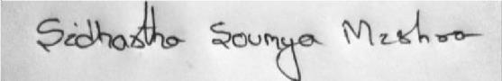
Date:
Place:Bhadrak signature

