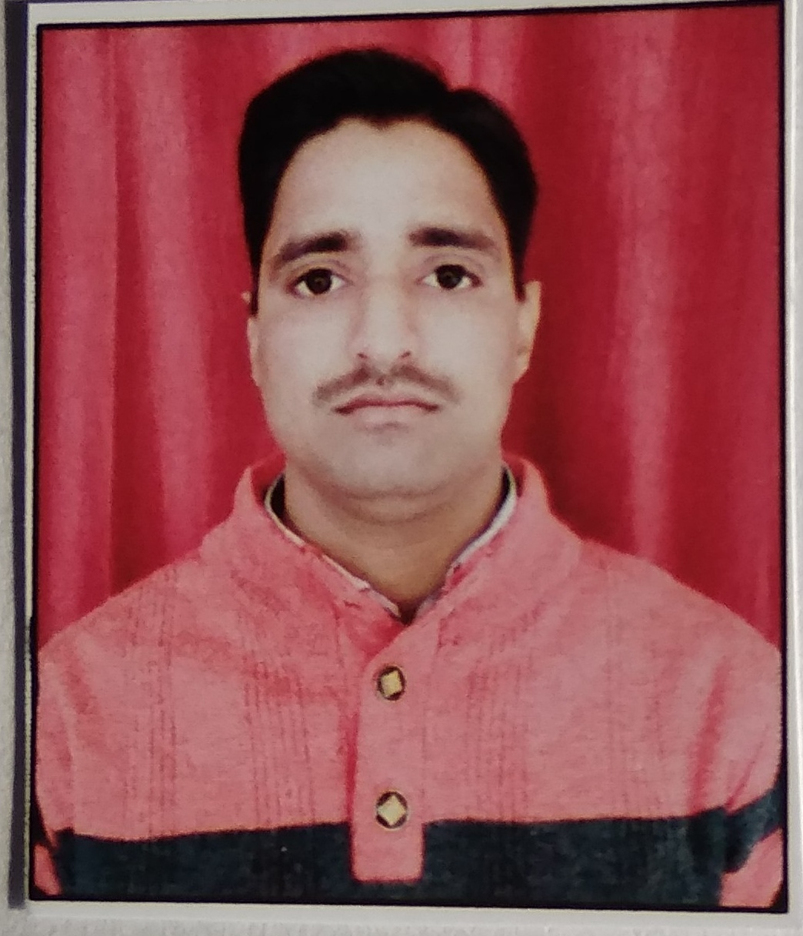
CURRICULUMVITAE

AMAN KUMAR VERMA

Adress:-
Vill : Raghunathpur
Post : Basara
Dist : Sitapur Contact: + 919415116974
Pin : 261141 E-mail Id : amanverma.av2014@gmail.com

CARRIER OBJECTIVE

Dedicated student with theoretical experience is seeking for organization where i can enhance my knowledge and give my best to the organization.

EDUCATIONAL QUALIFICATION

S.No | Qualification | College | University | Year of Passing | Marks
1 | High school | SVMI Collage Maholi Sitapur | Allahabad Board | 2008 | 40.4%
2 | Intermediate | K I C Maholi  Sitapur | Allahabad Board | 2011 | 66.7%
3 | B.Sc (Agricultural) | Janta Collage  Bakewar Etawah | CSJM University Kanpur | 2015 | 69.89%

OTHER EDUCATIONAL QUALIFICATION

- General Computer Application (Excel & WordPad)
- N. S. S. Certificate
- Food Preservation Diploma 15tn Days
- Rural Awareness Work Experience Certificate 6 month

WORK EXPERIENCE

- Working in Manikapur Sugar mile (a unit of B. C. M. L. Ltd.) from 03 March,2016
to 10 March,2017 as a Field Supervisor.
- Working in DCM Shriram Ltd., Sugar Unit - Loni (a unit of DCM Shriram Ltd.) from 02 Nov 2017 to 16/11/2020
now as a Field Supervisor.

KEY SKILLS AND STRENGTHS

- Initiative leadership qualities and co - operative
- Good communication skills and hard working
- Quick learner , ability to think positive and face challenges
- Would like to work effectively in a team or independently

PERSONAL DETAIL

Name : Aman Kumar Verma
Date of Birth : 25/09/1992
Father’s Name : Mr. Sumendra Verma
Nationality : Indian
Marital Status : Unmarried
Religion : Hindu
Language Known : Hindi / English
Hobbies : Reading Playing & Cricket.

DECLARATION
I hereby declare that all the above information provided by me is correct and best of my Knowledge and belief.
Place: - Sitapur AMAN KUMAR VERMA
Date: -

