RESUME



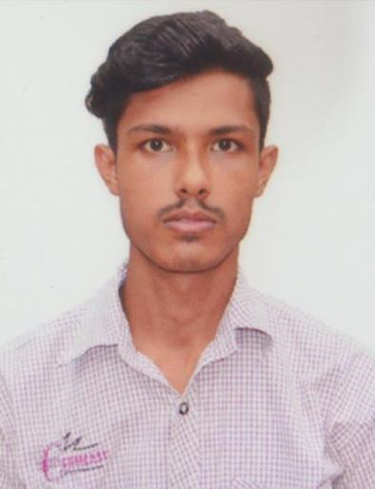
DAS
PALLAB
+91-8723922121

pallabdas54@gmail.com
Sonai Road, Saratpally
Lane No.3/1, House No.79
Silchar-6, Dist-Cachar
State-Assam

CAREER OBJECTIVE

Personal Details
DOB-10th Oct, 1994
Nationality- Indian
Gender- Male
Marital Status- Single
Religion- Hindu

To pursue my career in an organization with performance oriented achievement of personal advancement. Being ambitious and hard
working I am looking forward to challenging my potential and be
worthy of management trust and confidence.

EDUCATION
p
KEY SKILLS

Degree | School/University | Year | Percentage
H.S.L.C | Adhar Chand H.S School | 2010 | 42.5
H.S | Cachar College | 2012 | 39
B.B.A  (Marketing Management) | Assam Downtown University | Jul 2016-Jan 2021 | 71
- Sound analytical &
Reasoning skills.

- Strong communication &
Problem solving.
- Ability to co-ordinate, plan and evaluate projects Comprehensively.

- Effective team behavior.

- Diploma in Computer application (DCA) from Assam Rifles Institute of Information technology (ARIIT).
- Tally 9.0 also from Assam Rifles Institute of Information Technology (ARIIT)

CERTIFICATIONS
Interests
- Playing Cricket
- Reading Newspaper
- Listening old songs

PROFESSIONAL EXPERIENCE
Language Known
Assamese
Bengali
Hindi
English
Sales-Executive
Gitanjali Drug & Distributor/ Silchar / 2014-

Role:
- Offered each customer top-notch, personal service and polite support to boost sales and customer satisfaction.
- Greeted customer help located merchandise and suggested suitable option.

- Actively working with an NGO name – Robin Hood Army.

Declaration:
I do hereby declare that the information provided above is true to the best of my knowledge and belief.

Pallab Das
Date: Signature of the applicant
Place: Silchar

