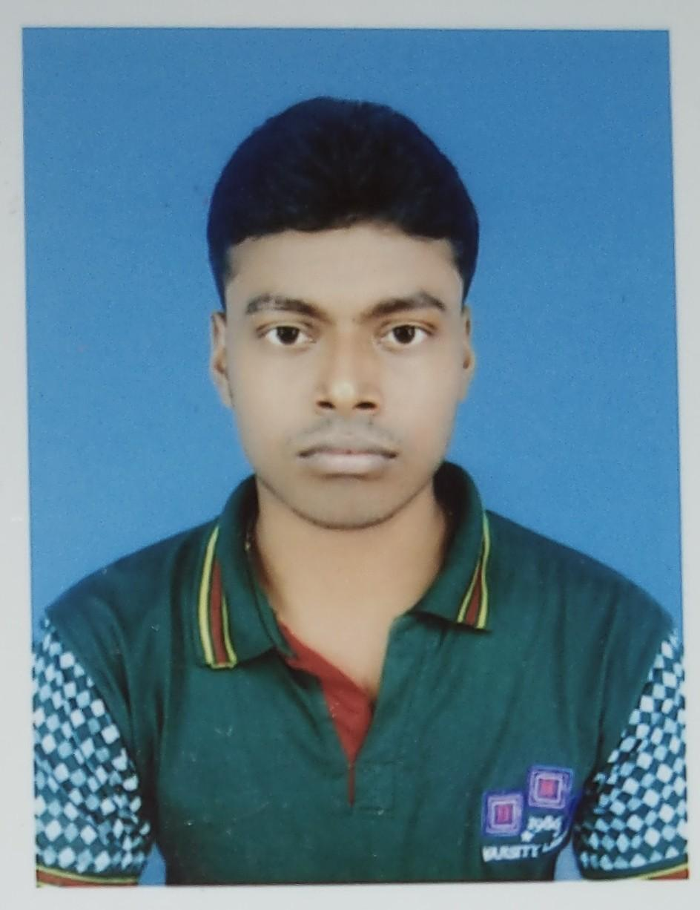
CURRICULUM VITAE

Personal details
Name : Rahul Maiti

Father's name : Late Lakshmi Kanta Maiti Sex : Male
Date of Birth : 03/05/1995
Marital status : Unmarried Nationality : Indian
Religion : Hindu

Career objective
I am looking for a challenging job where I can utilize my talent, knowledge & experience regarding ‘Radio therapeutic Technology Concern’. Also I want to learn working in the Organization and grow with the Organization.

Address :  Mobile No.:  Email :  Elora registration number | Vill- Kuldiha, P.O- Chaklahana, P.S- Debra Dist- Paschim Medinipur, Pin- 721126  918910586801  rahulmaiti33@gmail.com  20-00042
Age : | 26 yrs

Educational Qualification

Exam. passed | Board / University | Year of passing | Total marks of exam. | Marks obtained | Percentage of marks
Madhyamik | W.B.B.S.E | 2011 | 800 | 480 | 60%
H.S. | W.B.C.H.S.E | 2014 | 500 | 316 | 63.2%
B.SC. (H) | VIDYASAGAR UNIVERSITY | 2017 | 800 | 392 | 49%
Professional Qualification

Name of Course | Name of Board | Name of Institution | Year of Passing | Total Marks | Marks Obtained | Percentage
Diploma in | State | Saroj Gupta
Radiotherapeutic | Medical  Faculty | Cancer  centre & | 2019 | 300 | 198 | 66%
Technology | of | Research
(DRT),Tech. | West Bengal | Institute, Kolkata

Learn During DRT Course

- Linear Accelerators
  - Siemens ‘Primus Plus’(Conventional Dual energy,3DCRT)
  - Verian Unique (IMRT, RAPID ARC)
- Telecobalt machines
  - ‘Theratron Elite 80’.
  - ‘Bhabhatron II’.
- Digital Radiotherapy Simulator- Imaging (Panacea made).
- Brachytherapy machine – ‘MicroselectronHDR’ by Nucletron V2.
- Thermoplastic moulds ,vaclock electron cutout preparation.

Internship and Training Details
- Completed two year Diploma & 6 month internship in Radiotherapeutic Technologist course in August 2019, at Saroj Gupta Cancer Centre & Research Institute; Thakurpukur, Kolkata.
- Trained in linear accelerator at MEDICAL COLLEGE &HOSPITAL ,KOLKATA
- Varian TrueBeam (IMRT, IGRT, RAPID ARC)
- Trained in linear accelerator at NARAYANA SUPERSPECIALITY HOSPITAL, HOWRAH
- Versa HD (VMAT, SRS, SRT)

Current Employment Details
- Working as Radiotherapy technologist at SANJEEVANI CBCC CANCER HOSPITAL, Raipur from September 2020 to till now.
- Handling linear accelerator- Varian CLINAC DMX. (dual energy,120 MLC, OBI & EPID.)
- Handling Toshiba Asteion CT for patient simulation purpose.
- Experienced on treating the patients with following techniques of 3DCRT, IMRT, IGRT, RapidArc and SBRT.

Hobby
- Playing Cricket.

Other Activities & Interests
  - Like to watching news shows, animations and reading horror stories.
  - Listening to music.

Reference

- Mr. Prabhakaran ( Head medical physicist & RSO at Sanjeevani CBCC Cancer Hospital, Raipur Chhattisgarh)
Email: prabhakaran@cbccusa.in Mob. No. +91- 8248389088

- Preeti John Kujur ( Head radiotherapy technologist at Sanjeevani CBCC Cancer Hospital, Raipur Chhattisgarh)
Email: preeti@cbccusa.in Mob. No. +91- 7999706322

- Rajdip Mitra ( Medical Physicist at Kolkata Medical College & Hospital) Email: rajdip.mitra.1212@gmail.com
Mob. No.: 9903624145

Declaration
I do hereby declare that all the above statements made here are true to the best of my knowledge & belief.

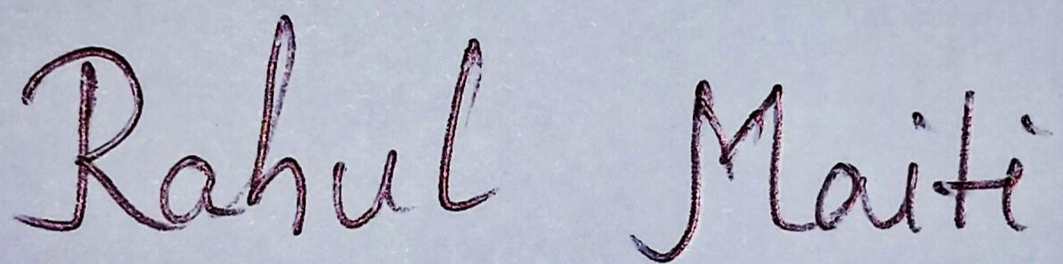
Date : 01.10.2021
Place : Debra, Paschim Medinipur, WB

Signature

