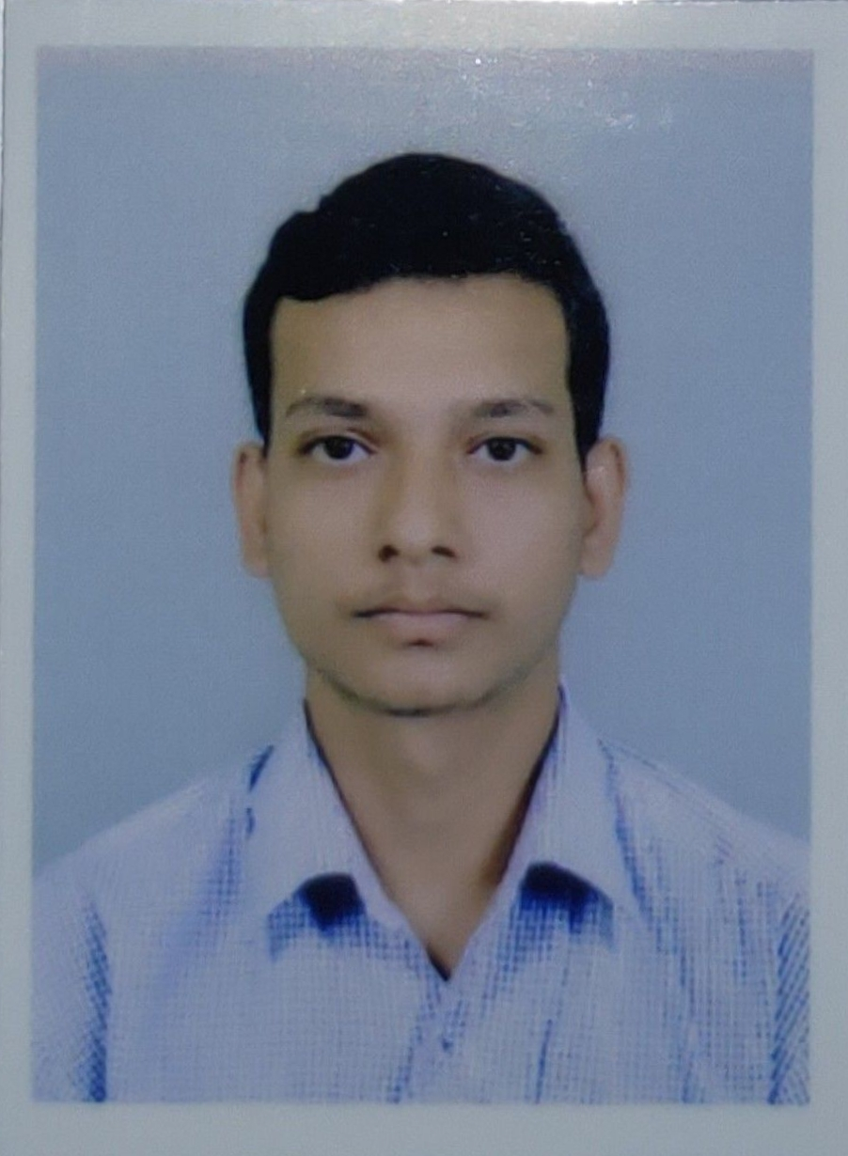
RESUME

Your Colour Passport Size Photo

Name: Suraj Mandal
Permanent Address: Teribeni,konchati,S.N Majumdar Road
Near Aghantuk club, Hooghly,712503

Email: surajmandal1805@gmail.com
Mobile: 7980470114
Career Objectives: To work in a creative environment with challenging assignments. Take learning experience which will help to gain experience and knowledge of the backend process. As a continuous development to face challenge and resolving them.

Academics:
Degree / Certificate | Discipline | Institute | Board /  University | Year of Passing | Aggregate  ( % / CGPA)
B.Tech | ME | Abacus Institute of Engineering and Management | M.A.K.A.U.T | 2022 | Pursuing
Diploma | ME | Supreme Knowledge Foundation Group Of Institutions | WBSCTVESD | 2019 | 77.6
12th | Hindi | Sahaganj Dunlop Hindi High school | W.B.B.H.S.E | 2016 | 58.80
10th | Hindi | RaghunathpurKesoram Rayon Vidyalaya | W.B.B.S.E | 2014 | 64.85

Additional Qualification / Achievements / Certifications: I have a certificate that, participated in the “TECH-QUIZ/EXPO-DE-SCIENTECH” in diploma.

Academic Projects: I have been done a academic project in Diploma where,I made “Remote Control Open Door System”.

Computer Proficiency: Basic knowledge of computer and AutoCAD.

Working Experience: I have been worked in Ashai India Glass Limited as a production engineer (November 2018 to April 2019).

Personal Profiles:

Father’s name: Laxmi Mandal
Date of Birth: 18.05.1998
Sex: Male
Nationality: Indian
Religion: Hindu
Languages Known: Hindi, English and Bengali
Hobbies & Interests: watching movies, listening music

Key Features:
- effective technical skills.
- the ability to work under pressure.
- problem-solving skills.
- teamworking skills.

References & Documents Available on Request:

Above mentioned particulars are correct according to my knowledge & I bear the responsibility for the correctness of above.

Date:

Place: Tribeni Suraj Mandal

Full Name

