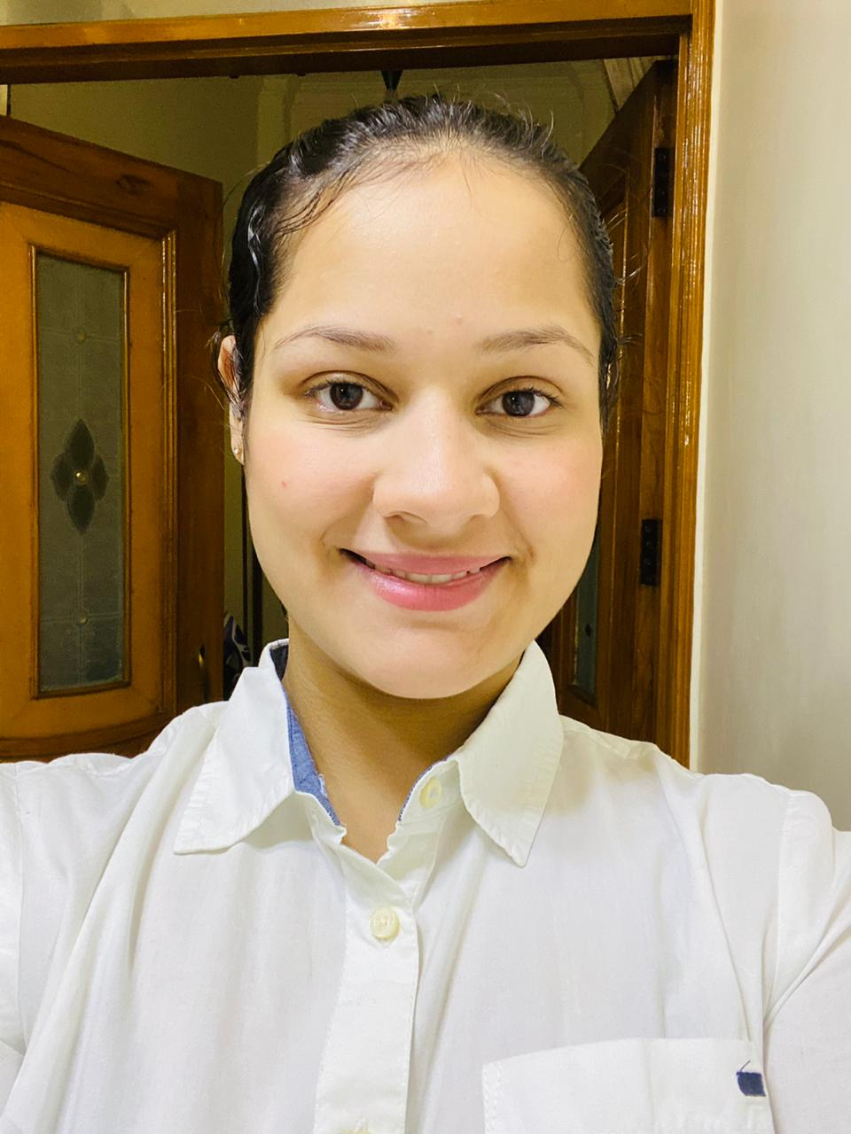 |  |  |  | Muskan  Kohli

Experience
Work as an employee in india mart company.

Education
YEAR OF PASSING | INSTITUTION/  COURSE | EXAMINATION | PERFORMANCE
2016-17 | Goodley Public  School | Secondary Examination, CBSE | 9.4 C.G.P.A
2018-19 | COMM. WITH MATHS, Goodley Public School | Higher Secondary Examination,  CBSE | 82.75%
2019-22 | BBA, GGSIPU | Undergraduation | Undergraduation

Communication
Good Communication Skills and Presentation Skills,
Can converse in Hindi and English.

Personal Skills
Commitment to deadlines, Punctual in time management

Career Objective
Being a result oriented, determined and a dynamic person, look forward to be an useful member towards an organization sharing a rewarding relationship where I am appreciated for my valuable inputs also currently upgrading my skills and knowledge.
A-15, GTK Road, Adarsh Nagar, Near Adarsh Nagar Metro Station,
Delhi-110033
 |  | +91 9899937152
 |  | muskankohli0212@gmail.com

