CURRICULUM VITAE
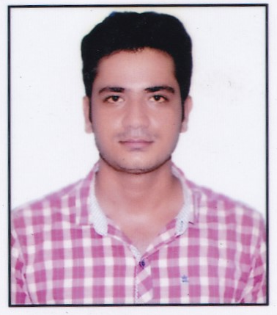
BADRI NARAYAN
- Engg Diploma In Mech.
- ADIS (2019-20)
- E-Mail: badrinarayantiwari1997@gmail.com
- Contact: +91 9415546737

CAREER OBJECTIVE
- To obtain a safety officer position with “Global Advantage and ensure workplace activities are in compliance with the federal regulations and standards.

WORK EXPERIENCE-3.9 Years
- Jr. HSE officer at NTPC Tanda 2*660 Mw Thermal power plants in Utility power tech limited. (From 2 Nov 2016 to 30 April 2019.)
- Jr. HSE officer at NTPC Tanda 2*660 Mw Thermal power plants in Utility power tech limited. (From 1 April 2020 to 31 July 2021.)
- EHS Engineer at GE Power India Limited at Simahdri NTPC Super thermal Power Plants.(From 30.09.2021 to Till)

EDUCATIONAL QUALIFICATION
- Advance Diploma in Industrial safety from MSBTE, Devi Mahalaxmi College (2019-20) with 89.27% Marks.
- 40 days E-Learning course in Industrial safety from NSC with “A” Grade.
- Diploma in Mechanical Engineering from BTE UP in 2016 with 71.22 % Marks
- 12 th from UP Board in 2013 with 66.5 % Marks
- 10th from UP Board in 2011 with 66 %. Marks

TECHNICAL SKILLS
- Microsoft office, Excel & PowerPoint
- Course on computer concepts (CCC) From NIELIT.
- Strong mathematical skills
- SAP operating skills.

TRAINING
- NTPC Tanda Ambedkar Nagar (U.P) :- 30 days summer training.

CORE COMPETENCIES
- Time Management
- Team work & Punctual.
- Can face the challenges.
- Leadership.
- Hard Working, Honesty & Optimistic
- Good Interpersonal skills, Communication & Analytical Skills

NATURE OF WORK:
- Induction &; Trainings.
- Inspection of machines, safety equipment’s & Portable tools.
- Documentation.
- Work permit.
- Site visiting/Audits.
- Hazard Identification & Risk Assessment.(HIRA)
- To check method statement/lifting plan before lifting any critical activity.

ROLES AND RESPONSIBILITY
AS a HSE officer
- Inspects the site to ensure it is a hazard-free environment.
- To conduct a safety awareness / Training program for Employees & Workers.
- To conduct on job site training program and toolbox talk regularly for workers and Engineers.
- Daily Unsafe act/condition observation & Inspection at work site.
- All incident/ accidents/near miss/Dangerous Occurrence investigate and implement Corrective action at site.
- Motivate employees to use of PPEs and ensure the quality of PPEs.
- Verifies that all tools and equipment are adequate and safe for use.
- Promotes safe practices at the job site.
- Trains and carries out drills and exercises on how to manage emergency situations.
- To conduct BBS (Behavior based Safety) training at site.
- Watches out for the safety of all workers and works to protect them from entering hazardous situations.
- Maintain good and bad practices reports.
- Conduct internal walk schedule for agency in every month.
- Conduct a monthly safety score card for specific safety points of every agency.
- Conduct the fire, Electrical, scaffolding etc. training to workman.
- Maintaining the Company Standard and BOCW Rules.

PERSONAL DETAILS
- Father’s Name : Ashok Tiwari
- Date of Birth : 04th May 1997
- Sex : Male
- Marital Status : Unmarried
- Nationality : Indian
- Permanent Add : Vill- Shivpur Kala ,
Post- Shivpur ,Kohandaur ,Pratapgarh(230401)

DECLARATION

- I do hereby declare that all the information as mentioned above are true and correct to the best of my knowledge and belief. Anticipating your earlier and favorable response in this regard, for this kinds of yours I shall remain grateful to you forever.
Date: ………….
Place: Pratapgarh, UP
BADRI NARAYAN

