Anthony Ranjeet Davis 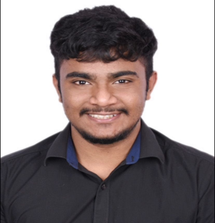
#22 16th cross 2nd A main road Vignan nagar Bangalore
Father’s Name Ratan Joseph Loyola Kumar
Date of Birth 05-12-2000
Sex Male
Marital Status Single
Nationality Indian
Language English, Tamil ,Kannada , Hindi,
Hobbies Cricket, listening to Music.
Skills Team worker, Communication, Leadership,
time Management, Problem Solving.

Educational Qualifications
Graduated my 10th from Bethany High School
2Nd P.U.C from Cathedral Pre University
Pursuing U.G .C in B.com at St. Joseph’s College (Autonomous)
( Will be flexible with any timing as my college and course ends by 11 am)
(Severed as the Joint Secretary of the commerce council in my 1st year 2020-21)
I, believe that the information mentioned above is true to the best of my knowledge.

