




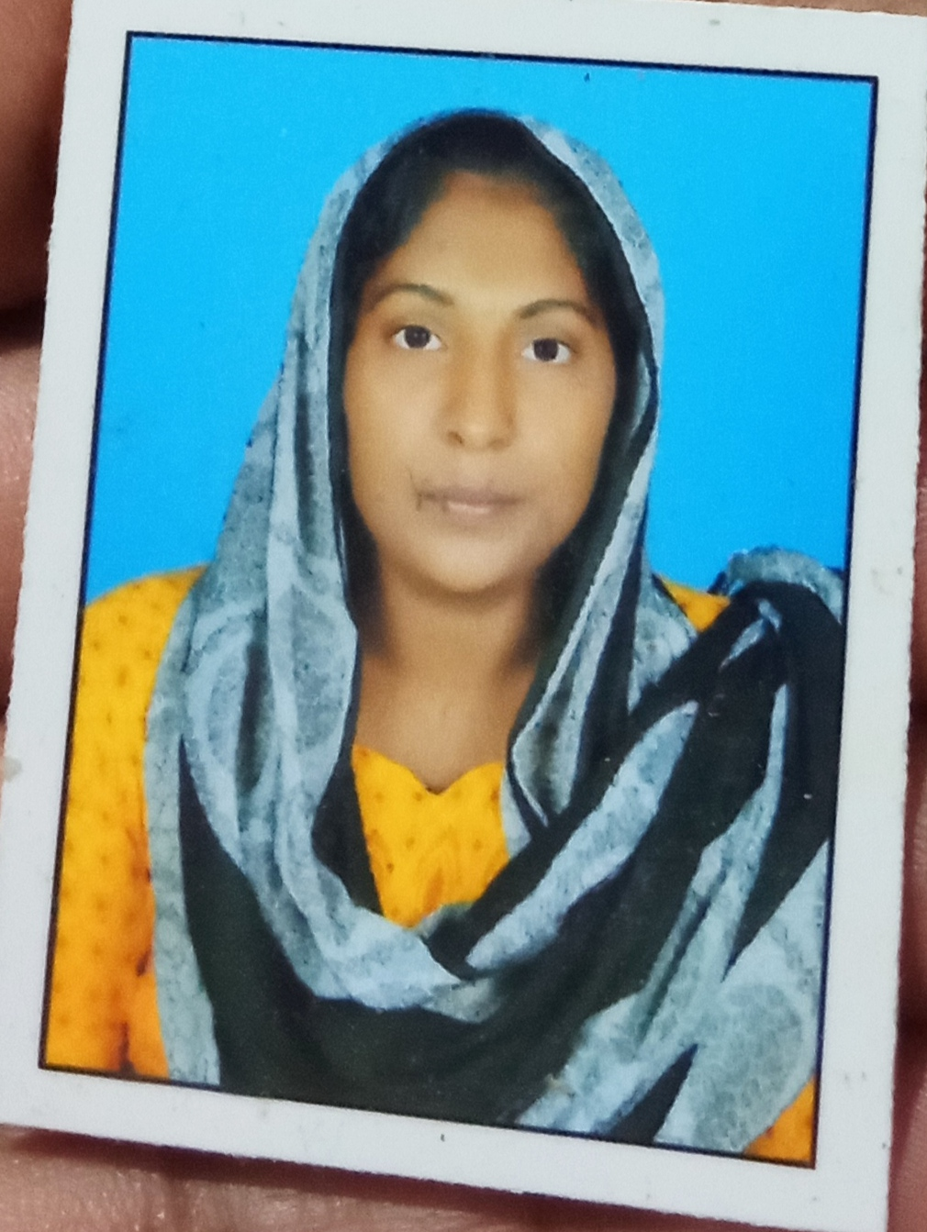
RESUME
LANGUAGE
PASSION
EDUCATION
reading, writting

9746064053
SOCIAL AUDIT OF KERALA-2year
(VELLEGE RESOURCE PERSON )

MALAYALAM
ENGLISH
- Indonesia
EXPERIENCE
CONTACT

NAME :MUMTHAS. A
ADRESS:PALLIYUDE THEKKATHIL
PALLISHERICKAL P. O
SASTHAMCOTTA
FATHER NAME:MUHAMMED RAJU
CAST :O B C
RELIGION :MUSLIM
MERITUL STATUS:MARIED

DATE OF BIRTH:30-5-1993
Sex :FEMALE

mumthasnajeem1530@gmil.com
mumthasnajeem1530@gmmail.com
S. S. L. C
+2/COMMERCE /TYPWRITTING-
(Malayalam @English )
I T I(DRAFTSMAN CIVIL@AUTOCAD-2D@3D

