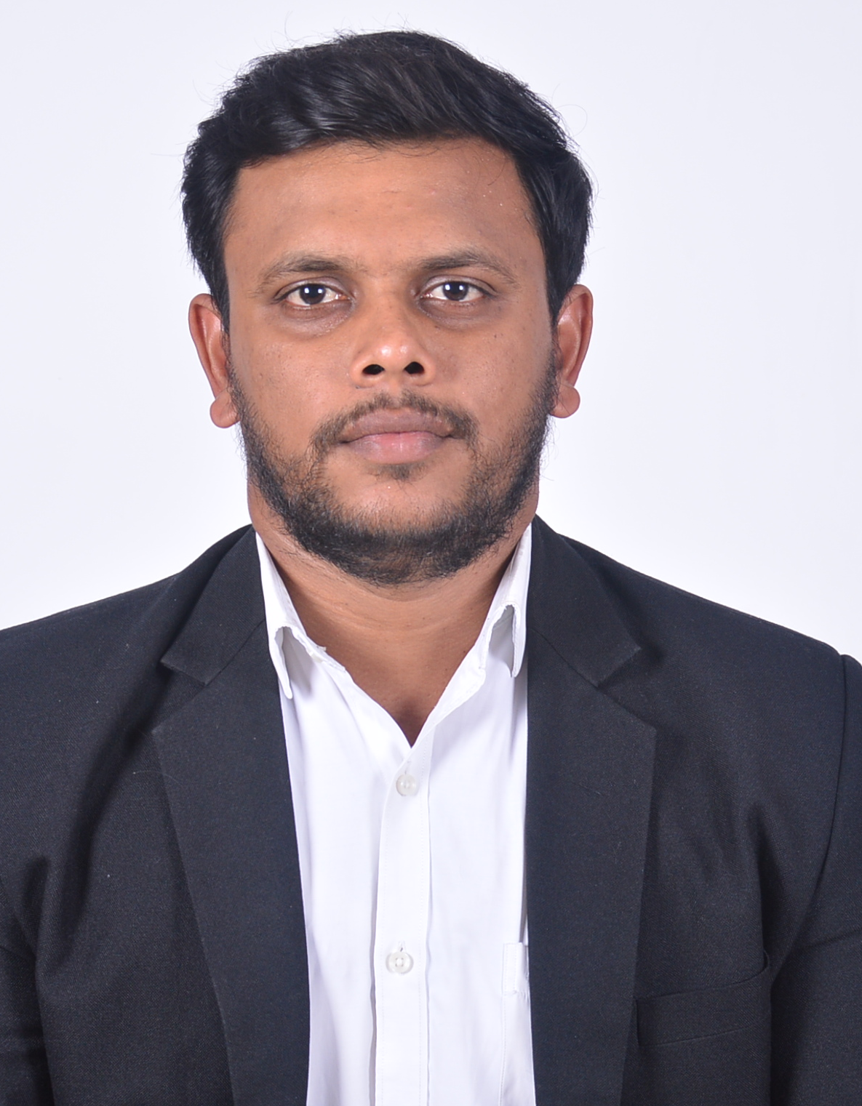

SHRI. KABIR PRAKASH BUGDE
H. No. 106/1, Mainath Bhatti,
Arpora, Bardez- Goa, 403516.
Mob.: +91 7020279158/9049449192
Email id: kabirbugde@gmail.com

Career Summary

- A dynamic & competent professional with over 11 years of experience as an Practicing Advocate in Civil and criminal cases and simultaneously 4 and half year experience as a Legal Advisor for a Private company in Panjim.
- Proven ability to represent the clients in complex and challenging environments.
- An accomplished professional who has successfully managed case preparation and court proceedings.
- A quick learner who can quickly absorb new situations and can communicate clearly and effectively with both legal professionals and members of the public.
- Presently looking for a lawyer’s position that provides a high level of job satisfaction and is also diverse and challenging.
Key Competencies & Skills
- Good knowledge of Civil, Criminal, Administrative, Real Estate, land law etc.
- Desirable depth knowledge of legal documentation and research.
- Well verse in drafting affidavits, power of Attorneys, sale deeds, gift deeds, Agreement for sale, Deed of Rectification, Deed of Relinquishment, leave & license, Memorandum of understanding, contracts, civil suits, Mundkar, Tenancy, Mutation, Partition, 138 NIA etc.
- Possessing the ability to convincingly present a case in court.

Key Responsibilities Handled
- Practiced as an Advocate in the District and Sessions Courts, JMFC Courts, Consumer Forums, Dy. Collector & SDO, Mamlatdar and other land revenue courts and has successfully conducted litigation in a variety of cases.
- Instituted legal proceedings for private clients in various issues relating to land, Mundkars, tenants and other properties and obtained favorable settlements in 75% of cases.
- Provided institutional clients with consultancy, legal opinions and appeared on behalf of them before various Forums.
- Filed cases for recovery of money due to banks and other institutions.
- Appeared for the accused in Criminal trials before the Magistrate’s Courts and before the Sessions Court in the Appellate Stage.
- Prepared and moved Second Appeals for clients in the civil appellate side.

Employers
- Worked as an Associate Advocate for Adv. Suresh Pilarnekar and Adv. Sakharay Naik from June 2010 till October 2016.
- Thereafter started practicing independently.
- Simultaneously, during the course of my independent practice I was also giving Legal advisor or was a retainer for F.V.Travles Pvt. Ltd situated in Panjim and its sister concern companies i.e M/s. Talent Hunt Recruitment Consultancy, Arabian Training & Testing Center (Trust), Sai Nirmal Mahila Udyog (Trust), NB Orange Business Development LLP and the its upcoming project Be Human United Pvt. Ltd and I was paid INR 50,00,000/-per month towards my legal fees.
Educational Details
Standard | Board | Percentage
LLM | Goa University | 55%
LLB (Hons.) | Goa University | 53%
HSSC | Goa Board | 53 %
SSC | Goa Board | 47 %

Additional qualification

Standard | Board | Year
Advance Computer Application | Salgaonkar’s Computer Center | 2012
Basic Computer | Aptech Computer Education | 2005
Accounting Application | NIIT | 2004

Extra Curricular Activities

- Nationalist Youth Congress, Marathon Race 3 kms.
- Participated in sports at Inter-School and Inter-College level.

PERSONAL DETAILS:

Date of Birth : 6th December 1987
Place of Birth : Goa – India
Nationality : Indian
Marital Status : Bachelor
Religion : Hindu
Languages Known : English, Hindi, Konkani,
Marathi, Understand Portuguese

Reference

Shri. Suresh Pilarnekar, Advocate, having office at S-1, Yashoda Smruti Bldg., 2nd Floor, Dovornem, Merces P.O. St. Cruz, Goa. 403 005.
Ph.: 0832-2449495,
Mob.: 9890513398.
Email: spilarnekar@yahoo.com

Shri. Sakharay Naik, Advocate, having office at 4th Floor, Neelkamal Arcade, Dr. Pissurlekar Marg, Panaji, Goa.
Mob.: 9822155028.
Email: sakharaynaik@yahoo.com

Declaration

I hereby declare that the above furnished details are true and correct to the best of my knowledge and belief. If offered I promise to take up the job with full sense of responsibility and dedication.

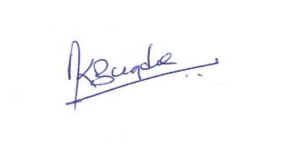
Kabir Bugde
Advocate

