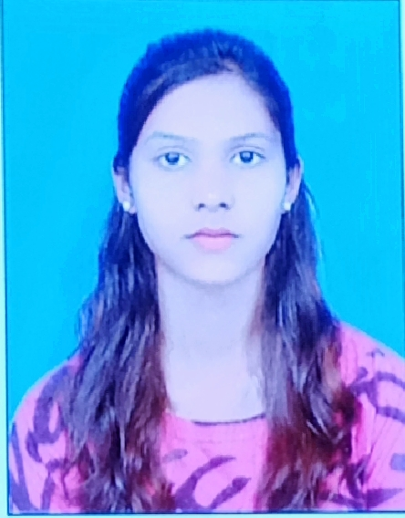
CURRICULUM VITAE
RIYA SHARMA
Address H No 1408/B , Zone No 6
Birsanagar, Jamshedpur
P O & P S – Birsanagar Contact No - 7970606804
Jamshedpur – 831004, Jharkhand Email : riyasharmajsrrr@gmail.com

CAREER OBJECTIVE
- To gain experience and get an opportunity to work in an esteemed organization which would help me explore my skills and gain a learning experience in a completely different environment.

ACADEMIC QUALIFICATION
EXAM PASSED | Board/Univ | Year of Passing | DIVISION
MATRIC | JAC | 2016 | 1st
I.Com | JAC | 2018 | 2nd

EXTRA QUALIFICATION
- DCA, Tally ERP 9

WORK EXPERIENCE
6 months experience in Fair advisory and legal services.
6 months experience in common service center.

PERSONAL DETAILS
- Father’s Name : Late Suresh Sharma
- Date of Birth : 17/07/2001
- Religion : Hindu
- Marital Status : Unmarried
- Gender : Female
- Language Known : Hindu & English

DECLARATION
I hereby declare that the above information are true to the best of my knowledge and belief.
Place : Jamshedpur (Signature)

