CARRICULUM VITAE
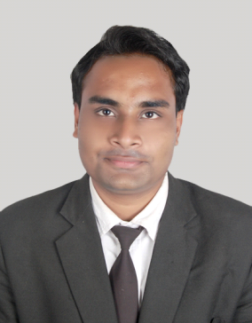
NAME: CHINMAYA MOHANTY
ADDRESS: 2nd floor Somya Complex, Basanti Colony Road,
Uditnagar,Rourkela-769012
Present address : 2nd floor Somya Complex,Basanti Colony Road, Uditnagar, Rourkela 769012
Mobile No: 9583251608, 9902274943
Email : cheenoo.m@gmail.com
DATE OF BIRTH : 21st November 1990
STATEMENT OF PURPOSE:
It had been my school day perception to enter into a stimulating and challenging Managerial role
in hospitality ,sales and customer relationship operations .Step by step I started grooming myself for this career. And
now through years, I am in a position to use my excellent interpersonal communication ,leadership and
management skills to make a dellible contribution in achieving the goals of the Company I join ,and confidently
Lead a team. .
SKILLS & ABILITIES:
Languages : Oriya, Hindi, English
I am a patient listener, have team management and leadership qualities. For me its a pleasure to
mix and interact with people and have the natural ability to win their trust. During my training
experience in Radisson Blu Hotel,GRT Chennai, I have been able to ensure customer satisfaction
at the Front Office , F & B Services. I have excellent communicative skills in English, Oriya and Hindi
I am well versed in serving the Customer and solving their problems, managing events and understanding administrative activities,vendor management,hygiene,facility management , logistics and sales.
WORK EXPERIENCE:
1. I underwent Industrial Exposure training at RADISSON BLU HOTEL,GRT CHENNAI, a 5 star facility,
for 115 days in Front office, House Keeping & B services during peak tourist season. I was awarded the
highest "E"(excellent) grade for my performance over there.(05/11/2013 to 28/02/2014)
My specialization had been in Front Office, House keeping and F & B service.
2. Worked with Hotel Arya Palace, Bhubaneswar as Guest Relation Associate from
5th April 2014 to 15th May 2015.
3. Worked in Citrus Hotel Lonavala, as Guest Relation Associate in Front Office from
20th of May 2015 to 30th October 2015.
4. Worked with Cafe Coffee Day, Bengaluru, as Assistant Manager from
1st of November 2015 to 30th March 2016.
5. I was with Prestige Golfshire, Nandi hills, Bengaluru, (an unit Managed by Troon
Golf, England) as Guest Relation Executive since 31st March 2016 till date. 25th November 2018.
6. I was with Stanza Living an unit of Dtwelve space ,Bangalore,since 1st of May 2019 till 25/02/2020 as Property
Manager.
7. I was working with D N Homes,Bhubaneswar ,top real estate company in Orissa,as Sales Manager from 05/02/2021 to
30/08/2021.
My work in Prestige Golf shire entailed:
    - Attending High Profile and Elite guests . Looking after their needs and problems and golf course allocation.
    - Selling membership of the club.
    - Allocating work to the team and scheduling.
    - Looking after the club upkeep, hygiene and inventory ;Duty roster and posting report to the AsstGM.
    - Pro shop management.
My work in Stanza Living entails:
- Own end to end operational responsibility of the residence
- Ensuring the delivery of various services food,hospitality,internet,laundry and security
- Monitor processes and improve service quality of different vendors.
- Perform operational duties contributing to team effort by accomplishing results as needed.
- Manage housekeeping by creating checklist for housekeeping staff,conduct regular audits based on the checklist,highlight for inefficiencies.
- Coordinating and multi tasking job duties in a busy environment,understanding customer requirement.
EDUCATIONAL QUALIFICATION:
- BACHELOR IN HOSPITALITY MANAGEMENT SERVICES Utkal University of Culture April 2015
- BACHELOR IN COMMERCE Sambalpur University April 2013
- ADVANCED DIPLOMA IN COMPUTER APPLICATION ABBSOFT COMPUTERS Oct 2009
ACHEIVEMENT:
- Secured the highest grade "E" (Excellent) in Industrial Training at Radisson Blu Hotel GRT Chennai.
- Was PREFECT in my School,Sarswati Vidyamandir,Rourkela during my +2 studies.
- Awarded Customer Service Champ for the month of June 2015 by Citrus Hotel Lonavala
- Certified Mechandise and hygiene by Cafe Coffee Day.
https://www.linkedin.com/in/chinmaya-mohanty-598098104/
CHINMAYA MOHANTY

November 28, 2018

To Whom It May Concern:

This letter will confirm that Chinmaya Mohanty was be employed by Northland Holdings Company Private Limited (Prestige Golfshire) from 22nd March 2016 to present.

During his employment, Chinmaya worked as a Customer Service Executive. He is a responsible, hard working and dedicated individual. His pleasing personality coupled with his strong work ethic and team-like efforts made him well liked by team members and other HOD’s. If I had the opportunity to hire Chinmaya again in the future I would.

If you have any questions, please feel free to contact me.

Sincerely,

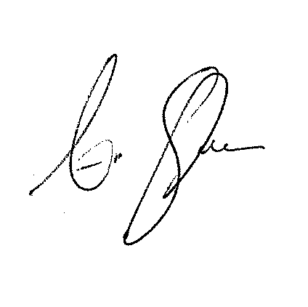
Andrew Stockinger

General Manager
Prestige Golfshire
astockinger@troon.com
+91 99000 39248

