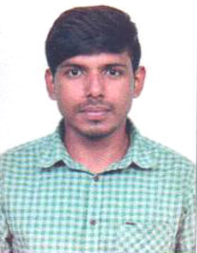
CURRICULUM VITAE

Name: Arijit Mondal
>Father’s Name: Late ChittaRanjan Mondal
>Address: JatinDas Road, Majherpara
Ichhapore
Dist- North 24 Parganas
Pin- 743144
>Date of Birth: 9th July, 1994, >Marital Status: Single
>Religion: Hindu, >Nationality: Indian
>Language Known: Bengali, English, Hindi
Contact No. 8981296589, 8017807086 E-mail:-arijitandres@gmail.com
CAREER OBJECTIVES
To work will full strength in dynamic organization which provide new challenges that help to add value to the organizations and the individual seeking a challenging career to value on time performance, where I can enhance my working skills, strength and experience which helps achieving target.
ACADEMIC QUALIFICATION
Degree | Board/University | Name of the Institute | Year | % of Marks
B.Sc (Hons.) | W.B.S.U. | Naihati Rishi Bamkim Chandra College | 2016 | 53.5
H.S. | W.B.C.H.S.E. | Naihati Narendra Vidyaniketan | 2012 | 69.4
Madhyamik | W.B.S.E. | Naihati Narendra Vidyaniketan | 2010 | 73.9
COMPUTER PROFIENCY
- Operating System : Windows 7, 8 & 10
- Application Software : MS Office, Internet Web Browsers
- Attending the 5 Days Training at Mudrabiz
WORKING EXPERINCE
- Worked as a Private Biology and Botany Teacher for 4 years
- Worked as a Junior and Senior Content Specialist in Achievex Solution Pvt. Ltd. And Assurex e-Consultant
- Permanent basis Freelancer (Academic Content Writter)
HOBBIES
Playing Football, Cooking, Photography & Editing and Gardening.

Date:
Signature

