SANEER SALIM
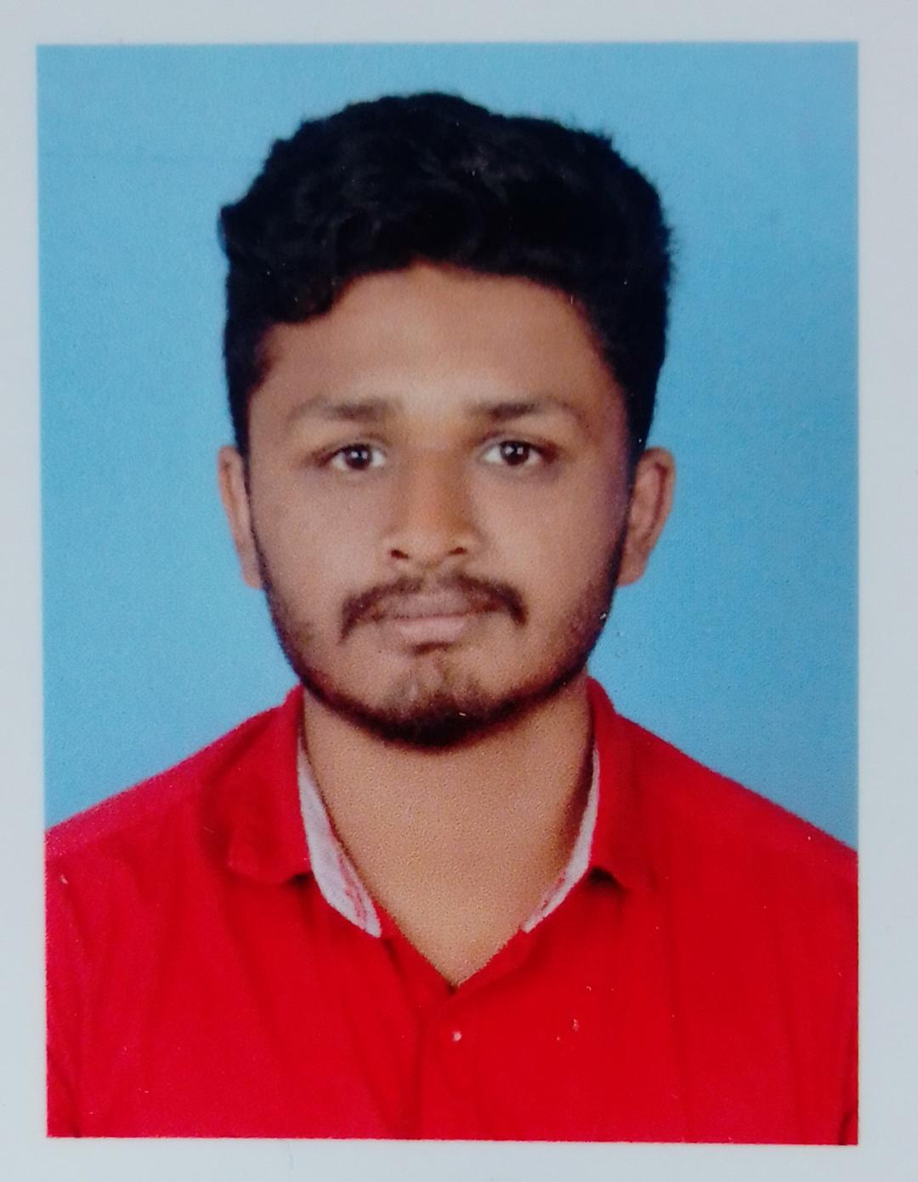
EMBEDDED SYSTEM ENGINEER
CONTACT
saneersalim111@gmail.com
7034385781
Thelliyil(H)Ramakkalmedu
P.O Ramakkalmedu
Idukki, 685552
LANGUAGE KNOWN
English -W\R\S
Malayalam -W\R\S
Hindi -W\R\
Arabi -W\R
Tamil - S
HOBBIES
Driving
Cricket
Kabaddi
Food tasting
SKILLS
Embedded C
Circuit Designing
Soldering
Matlab
Proteus
C++

OBJECTIVE
To work in an environment which encourages me to succeed and grow professionally where I can utilize my Skills and knowledge appropriately.
EDUCATION
• Govt.Polytechnic College, Nedumkandam – Electronics and communication Engineering (2020) , first class
• MES HSS Vandanmedu– Higher secondary-computer science (2017) 78%
• SHHS Ramakkalmedu – SSLC(2015)83%
EXPERIENCE
Soften technologies Cochin, March 2021-September 2021
Junior Embedded system engineer
PROJECT
Mini Quadcopter
Smart blind stick
INTERNSHIP
Soften Technologies, Cochin, September 2020 – February 2021
SOFT SKILLS
Team work
Time management
DECLARTION
I Saneer Salim, hereby declare that all the above information is correct and accurate to the best of my knowledge and belief.

