CV  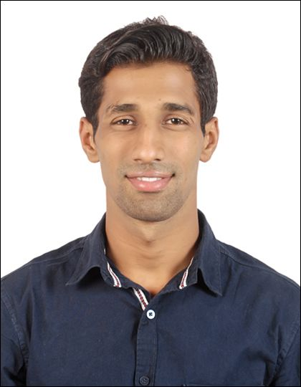  Sourav Biswakarma
  H-No - 4-16-58/1
  HIMAGRI NAGR,
  BANDLAGUDA,
  Hyderabad – 500091
  9437871294
  sourav.biswakarma52@gmail.com

Job Objective
- Intend to build a career with leading corporate of hi-tech environment with committed & dedicated people, which will help me to explore and realize my potential as well as serve the organization.

Education
- Matriculation (2008 - B.S.E.)
A.J.O. High school , phulbani , odisha with percentage of marks 66.85%.
- 12th (2010 - C.H.S.E )
GOVT. Junior College , phulbani, Odisha , Percentage of Marks 54.67%
- Diploma in mechatronics (2013 - N.T.T.F. )
N.T.T.F. Gopalpur, odisha, Percentage of Marks 76.16%
- PGDIIA ( 2019- PROLIFIC Hyderabad- PLC programming – simulation and hard ware interference )

Experience ( 8 + yrs )
- MAKINO INDIA PVT, LTD, BANGALORE, (D.E.T.) June 2013 - July 2014
- CNC programming , machine assembly , hydraulic , pneumatic & PLC conepectios. Engineering drawing

- TYCHE DIE CAST PVT, LTD. HYDERABAD ( Supervisor ) Aug 2014 -Sept2018
- CNC as well as PDC ( pressure die casting ) machine maintenance in both mechanical and electrical field.

- RANE ENGINE VALVE LIMITED HYDERABAD, ( Engineer ) Oct 2018 - Till now
- CNC and PLC controlled machines maintenance.
Automation:
Electrical Systems Troubleshooting on
- Cotrollers
- Fanuc ( OM SERIES)
- Siemens ( 802D & 828D)
- Mitsubishi ( M70)
- Drives (VFD)
- Fuji drives
- ABB Drives

- PLC
- PLC ( AB500, Siemens S7 300 , S7 200 , Delta DVP60ES2)

- Motors
- Induction & servo motors
- Break alignments.
- DOL & Start Delta connection, forward /reverse etc with control devices.
- Induction Heaters

Mechanical Troubleshooting on
- PUMPS
- Piston pump
- Vane pump
- Gear pump
- Linear and motion elements
- LM Block and rail
- LM bearings
- Ball screw
- Lead screw
- Special bearings.
- Pneumatics - hydraulic motion accessories
- Cylinders
- DC valves
- FC & check valves
- NRV s
- Solenoid valves
- Power transmission unit
- Sprockets, Gears and Chains, Belts, Pulleys, etc..
- Heavy duty parts
- Spindle
- Impeller
- Basting wheels
- High pressure injection unit

Dealed with machines like
- CNC MILLING (MAKINO , BFW, AMS WINNER) AND LATHE ( ASKAR , MAZAK , GEEDE WHEELER)

- Pressure Die casting Machine ( Toshiba- 800T, HMT- 250/420T, Zitai - 250/420)

- Shot blasting machine

- Furnace ( 10kW- 700’C)

- PTA welding machines

- Plc controlled grinding Machines.

- DG sets up to 1500 KVA.

- Air Compressors Up to 125hp.

- EOT cranes ( 5 ton)

- Hydraulic press Upsetters.

- Pneumatic & Hydro- pneumatic presses

Other responsibilities
- Documentation
- Breakdown updation.
- Spare control.
- Machine history record control.
- Updation of MTBF, MTTR, MTTF.

- New machine installation.
- Preventive maintenance planning.
- TEI & TPM
- Project works.
- Kaizen-poke yoke.
- Material follow up
- Safety activities.

Computer Knowledge
- SAP Plant Maintenance module
- MS office
- AutoCAD
- Pro –E ( solid modeling)
- Proteus
- PLC softwares.

Personality traits
- Adjustability
- Task oriented
- Reliability
- Discipline
- Team work

Language known
- English
- Oriya
- Hindi
- Telugus

Current CTC
- 4.6 Lakhs Per Annum
- Expected CTC: Negotiable

Personal Details

Name : Sourav Biswakarma
Father Name : Sarat kumar sahu
Marital Status : Un-Married
Languages Known : English, Hindi, Odia and Telugu.
Date of birth : 03-06-1993
Permnent address : C/O Natabara sahu , At- landei street , Po- bhanjanagar Dist- Ganjam , pin-761126
In view of above I am declaring that above mentioned details are true and to the best of my knowledge, so kindly consider my application for the above post and give me a chance to serve your esteemed organization

Place: Yours Faithfully
Date: (Sourav Biswakarma)

