RESUME
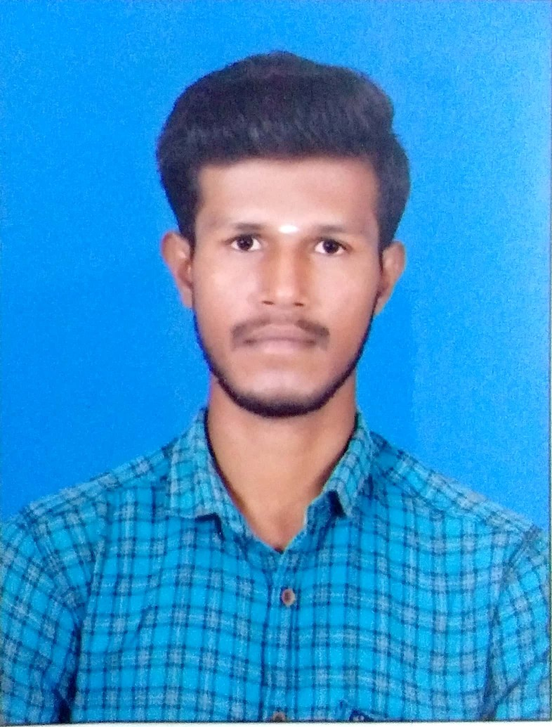
M.VALLATHU RAJA BE.Mech.
558/6 Indira Nagar, 3rd Street,Kovil Patti, Tuticorin-628501.

EMail id: vallathuraja007@gmail.com Contact: 8778894412

CAREER OBJECTIVE:
To accomplish a challenging position where I can effectively use my knowledge and skills to the betterment of organization and myself.

EDUCATIONAL QUALIFICATIONS :

COURSE | NAME OF THE INSTITUTION | BOARD/ UNIVERSITY | YEAR OF PASSING | PERCENTAGE
B.E  (Mechanical Engineering) | Shree Venkateshwara Hi- Tech Engineering  College,Gobi. | Anna University, Chennai | 2019 | 73.9%
HSC | V.O.C Govt Higher Secondary  School,Kovil Patti. | State Board, Govt of Tamilnadu | 2015 | 83%
SSLC | Viswakarama High School, Kovil Patti. | State Board, Govt of Tamilnadu | 2013 | 78%

AREAS OF INTEREST:

Automobiles and Design field Manufacturing field

PROJECTS PRESENTED:

- Presented project on "Reciprocating Motion Of Limestone Boulter Machine For Small Scale Industries" in the National Level Symposium on “TECHNOFEST19", held at PPG Institute Of Technology College and won 1st PRIZE.
- Presented a mini project on "Fabrication Of 180 Degree Dropping Dumper"in the National Level Symposium on “FASAHA’2K18”, held at Sasurie Engineering College, Coimbatore from 3rd March 2018 and got 3rdprice.

INDUSTRIAL VISIT:

SESHASAYEE Paper and Board, Pvt Ltd. WORKING EXPERIENCE:
COMPANY NAME :AQUA SUB Pumps Manufacturing.
DESIGNATION : Development Engineer and Vertical Turning CNC Machine
Setter, Programmer and Development Quality.
DURATION. : One Year and Six months.

PERSONAL PROFILE :

Date of birth : 21/05/1998

Father’s name : A.Muthuraj

Mother’s name : M.Lakshmi

Gender : Male

Nationality : Indian

Passport No : 7610293

Aadhar No : 984773987012

Languages known : Tamil, English.

DECLARATION :
I hereby declare that all the details given above are true to the best of my knowledge and belief.

Place:
Date: YOUR'S FAITHFULLY
(Vallathu Raja)

