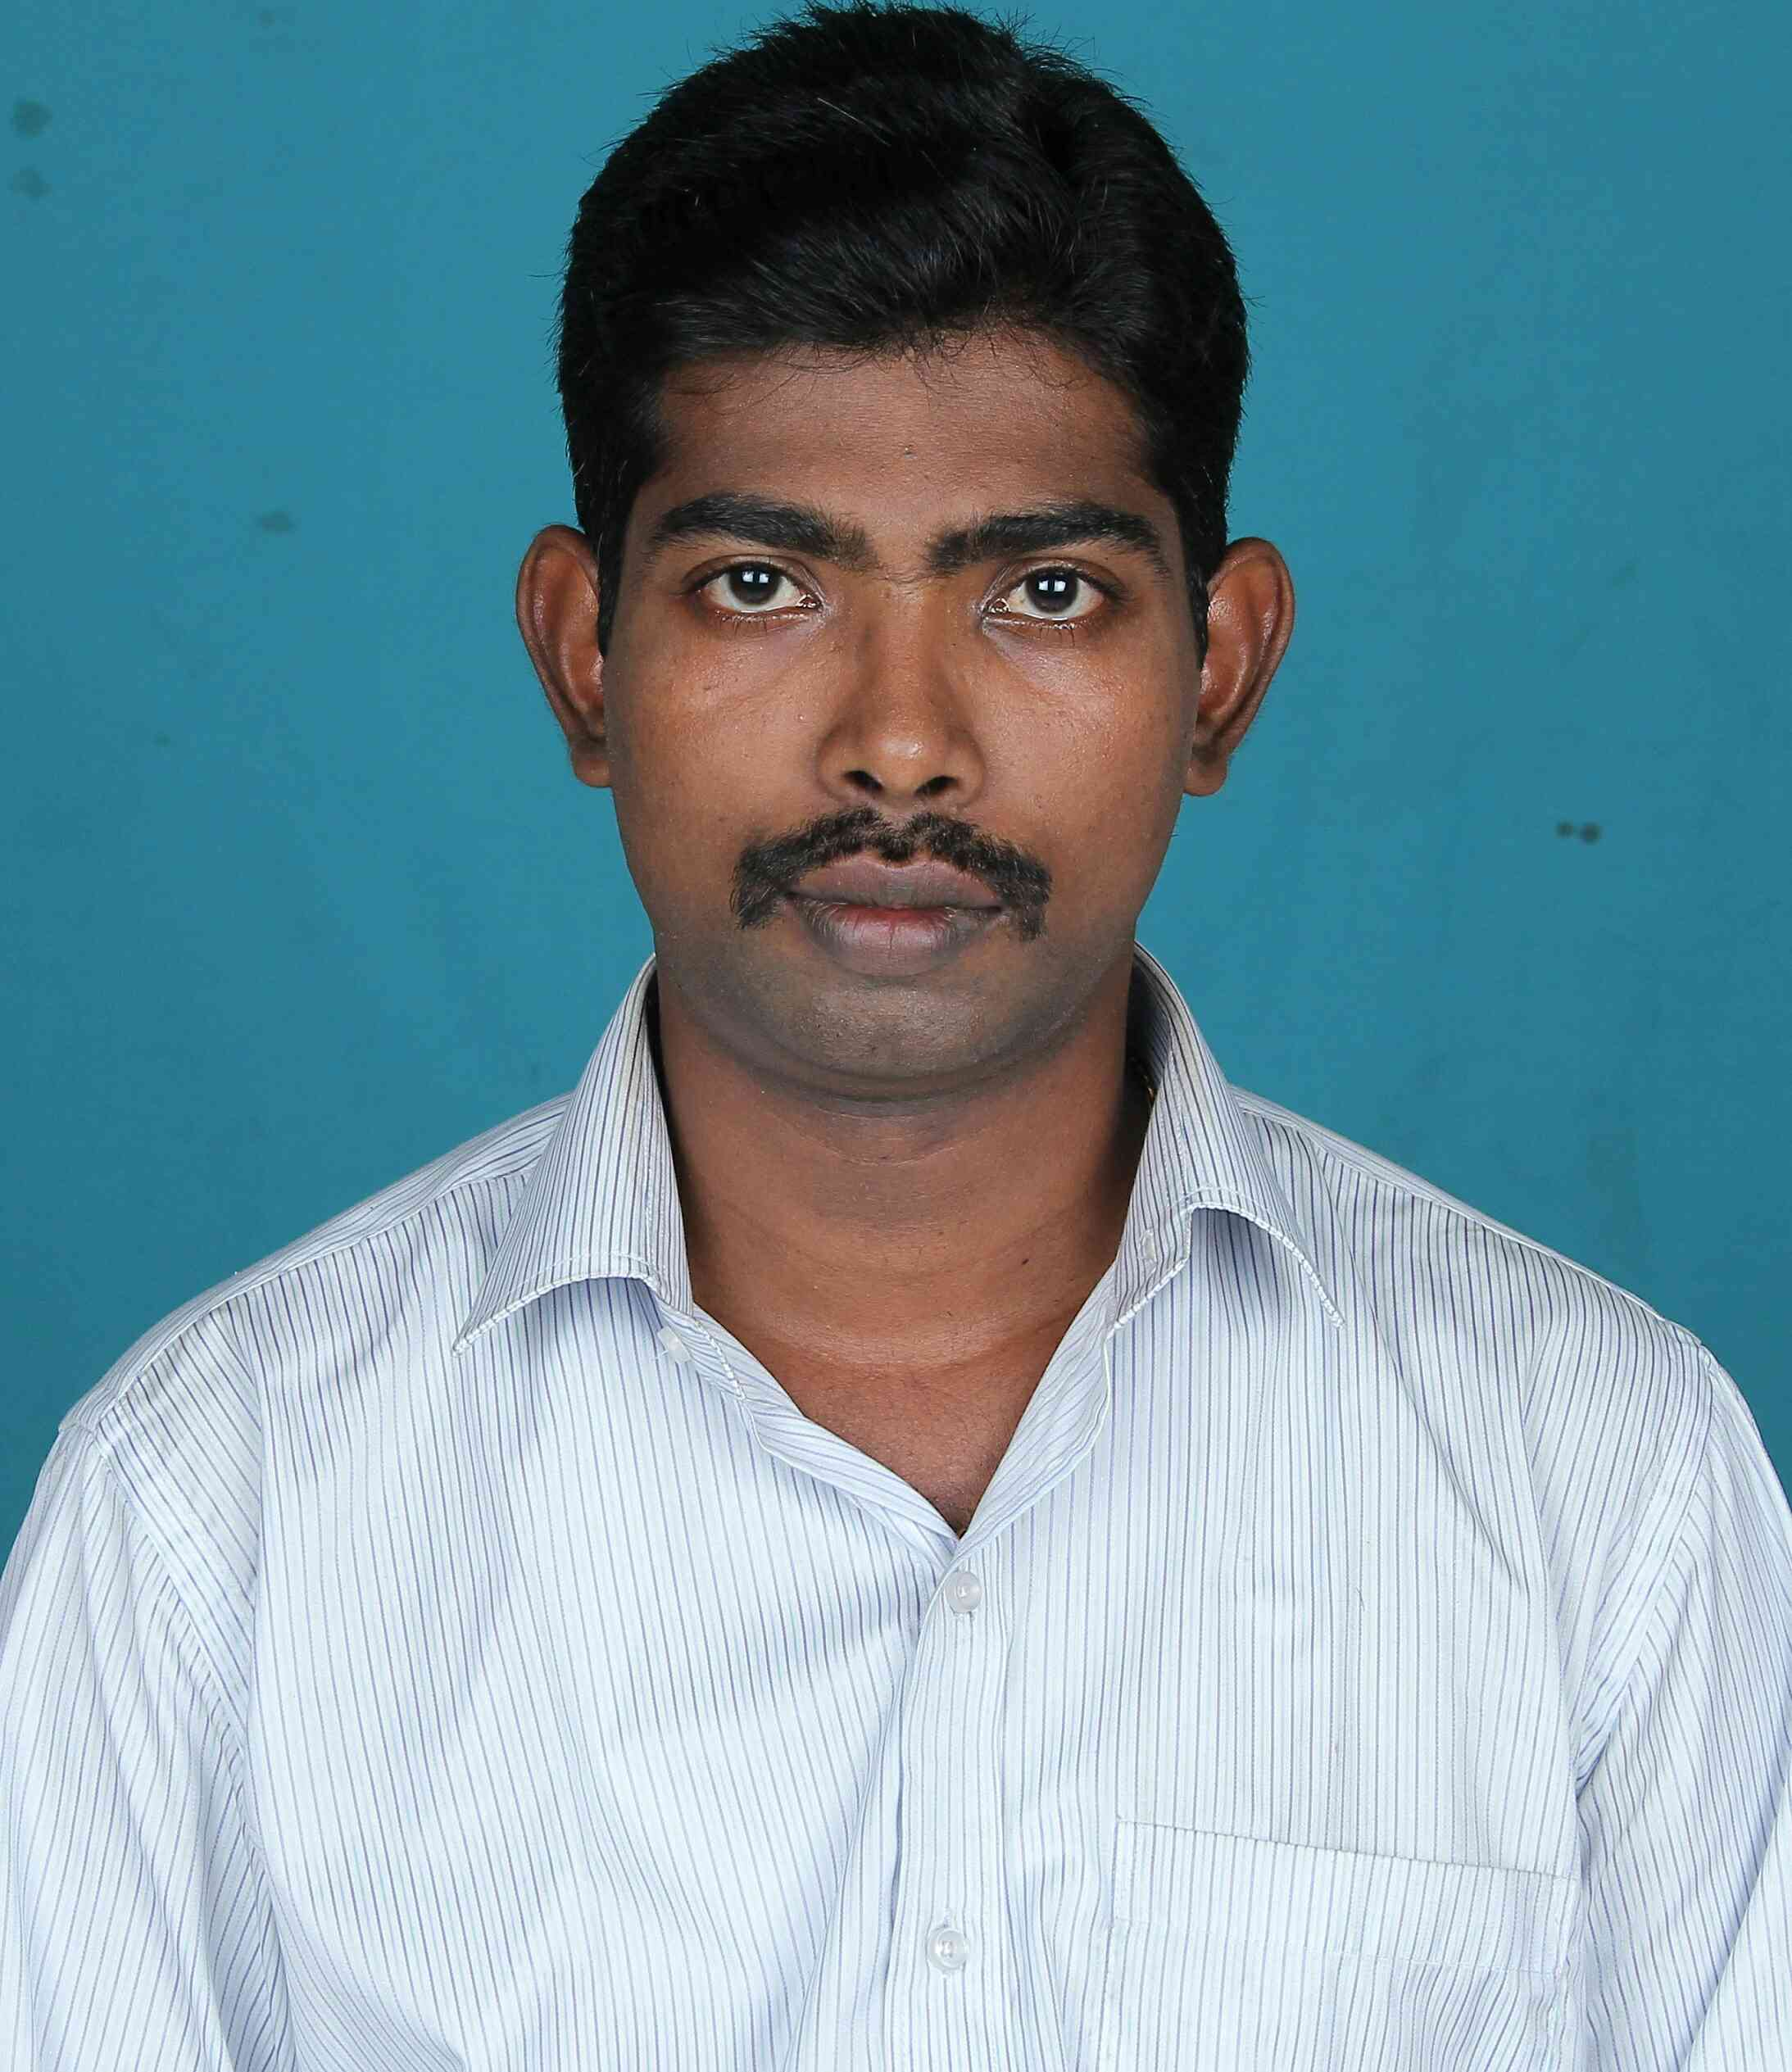
ASWIN N S
+91 9841 39 1432
edwinaswin@gmail.com
OBJECTIVE
To apply my talents at a firm where I can utilize my skills as a professional that encourages continued learning and creativity providing exposure to new ideas that stimulates professional and personal growth.
ACADEMIC QUALIFICATION :
- M.B.A Human Resources & Marketing (2014 – 2016) at Sathyabama University, Chennai- with 68%

- B.E. Mechanical Engineering (2010 – 2014) Sathyabama University, Chennai- with 65%

PROFESSIONAL EXPERIANCE

Total Experience : 4 Years
PARVEEN AUTOMOBILES
Works Manager
Deputed to : AB Trucks (TATA Authorized Service Station)
Duration : Feb’ 19 to Dec'19
Responsibilities
- Handling of shop floor for service activities, vehicles which are coming for regular periodic service, Warranty Repairs and Claims
- To develop service operations of TATA Vehicles for revenue generations as per company guidelines and norms
- Order of parts and to keep all records including stores documents, bills, etc., for audits
Unit Head
Deputed to : MotorZone
Duration : Nov’ 17 to Jan’ 19
Responsibilities
- Handling Multiband Vehicles to increase labor revenue as per management requirements
- Preparing estimates and coordinate with the customer and Insurance companies for accident vehicles also ordering parts and making VOR of parts for the vehicle
- Providing frequent awareness on product upgrades to technicians through proper communications and trainings
Floor Supervisor/ Service Advisor
Deputed to : Ashok Leyland Authorized Service Centre
Duration : Jan’ 17 to Oct’ 17
Responsibilities
- Supervising general servicing, Mechanical Overhaul and repairs of Ashok Leyland Trucks and Buses
- To maintain all company owned vehicles on road and availability of equipments for site work
- Allocating technicians for servicing vehicles based on the criteria of the requirement.
- Canvassing customers to increase the inflow of vehicles for service as a service marketing strategy
Marketing Executive
Deputed to : Motor Zone
Duration : June’16 to Dec’16
Responsibilities
- Discovered and secured new relationships with local organizations and increased profitability.
- Monitoring activities of competitors and Initiated, scheduled, organized and managed campaigns to sustain profitable relations
- Responding to different customer needs and answering customers inquires and keep the customers satisfied.

VIJAYA FABRICATORS
Quality Supervisor
Duration : Jan’16 to May’16
Responsibilities
- Establish priorities and ensure maximum usage of assigned resources
- Interpret and support quality policies and implement guidelines to ensure compliance with quality standards
- Monitor safety evaluate and review them in regular intervals and follow corrective actions if necessary

INPLANT TRAINING PROGRAMS
- In plant training in ASHOK LEYLAND, Ennore, Chennai
- In plant training in HONDA SERVICE CENTRE, Padi Pudhu Nagar, Chennai
PROJECT
- Load Monitoring display
Design of a load monitoring display in 3718IL model truck (to enable the cockpit members to be aware of the load in the vehicle) in Ashok Leyland, Ennore, Chennai
- Work place environment Study
A study on work place environment in Simpson & Company Ltd, Chennai (to study the comfort of the working area)
HOBBIES:
- Listening Music
- Driving
PERSONAL DETAILS:
Name : Aswin N S
Father’s Name : A Nakulan
Date of Birth : 09-11-1991
Gender : Male
Nationality : Indian
Religion : Christian
Marital Status : Married
Address : No : 1, Om Sakthi Lane,
Lakshmi Amman Nagar,
Erukkancherry, Chennai – 600 118.
Passport Number : N3985449

DECLARATION:
I hereby declare that the above furnished details of mine are true, complete and correct to the best of my knowledge and belief.

Place: Chennai-118.
Date:
(ASWIN N.S)

