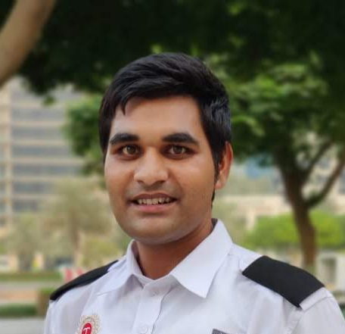  ARJINDER SINGH  Profession: Security system  Operator  CERTIFIED  SIRA APPROVED LICENCE HOLDER  SECURITY GURAD  SECURITY SYSTEM OPERATOR  BASIC LIFE SUPPORT  FIRE AND SAFETY  CUSTOMER SERVICE TRAINING    - Security System expertise  - Security ,Health & safety  - CIT expert  - Basic computer knowledge  - Marketing knowledge  - Good communication  - Leadership  PERSONAL DETAILS   Dubai, UAE   +971 55162 4349   Ar.arjinder@gmail.com  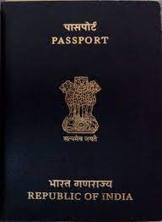PPA-M3700461  Age: 30 years  Nationality: Indian  Gender: Male  Marital Status: Married  .  EDUCATION HISTORY  LANGUAGES KNOWN  ENGLISH  HINDI  PUNJABI | CURRICULAM VITAE  CAREER OBJECTIVE  To secure a challenging position in a reputable organization to expand my learnings, knowledge, and skills. Secure a responsible career opportunity to fully utilize my training and skills, while making a significant contribution to the success of the company.  Key Experience: - 3 year experience of CCTV operator  Projects: -  - Global Village Park  - Emaar residences(Downtown)  - Dubai Creek Residences  - 4 Star Hotel (Novotel (Deira city Centre)  - 4 Star Treppan Hotel (Dubai Sports city)  .  COMPANY  - ISSSDB SECURITY SOLUTION  - SECURE VALUE INDIA LTD  - TRANSGURAD GROUP LLC  PROFESSIONAL HISTORY (FROM MAY 2013 TO DATE)  INDIA (May 2013 - May2018)  CASH IN TRANSIT 3year 1month  - ISSSBD Security Solution (India, Amritsar)  Cash operative executive( 1year 3month) (May 2013-Aug 2014)  Worked as ATM cash custodian (ICICI Bank)  - Secure value India ltd (India, Amritsar)  Cash operative executive ( 1year 4month) (Aug 2014-Dec 2015)  Worked as ATM cash custodian (HDFC Bank)  - Radiant cash management services (India, Amritsar)  Official Backup (6months) (Jan 2016-May 2016)  Worked as ATM cash custodian/ official back up (HDFC Bank)  IFAZONE (Marketing company) (India Chandigarh)  - MLM Business Advisor (7month) (July 2016- Feb 2017)  AREA SECURITY SERVICES (India, Amritsar)  - Security Guard (1year 2month) (Mar 2017- May 2018)  UAE, DUBAI (GULF EXPERIENCE)  TRANSGUARD GROUP LLC (OCT 2018 – TO DATE)  - SECURITY OFFICER (OCT 2018 TO SEP 2019)  GLOBAL VILLAGE PARK (Oct 2018-Apr 2019)  Worked as security officer in Carnaval (rides, games and attractions)  EMMAR COMMUNITIES (Apr 2019-Sep 2019)  Worked as security officer in residential building(Old Downtown)  - SECURITY SYSTEM OPERATOR (SEP 2019 TO TILL DATE)  EMMAR COMMUNITIES (Sep 2019-Mar 2021)  Worked as CCTV operator in residential building  ( Downtown Dubai)  - HOTEL EXPERIENCE  NOVOTEL IBIS HOTEL (Apr 2021- Sep2021)  Worked as CCTV operator in 4 star Hotel ( Deira city)  TREPPAN HOTEL & SUITES (Sep 2021- till date)  Worked as CCTV operator in 4 star Hotel (Dubai sports city)
  YEAR | QUALIFICATION | BOARD | %
  2008 | 10TH | CBSE | 72
  2010 | 12TH | CBSE | 74
  2011 | DCA |  | 65

