LAVANYA V
Mechanical Engineer
PROFILE

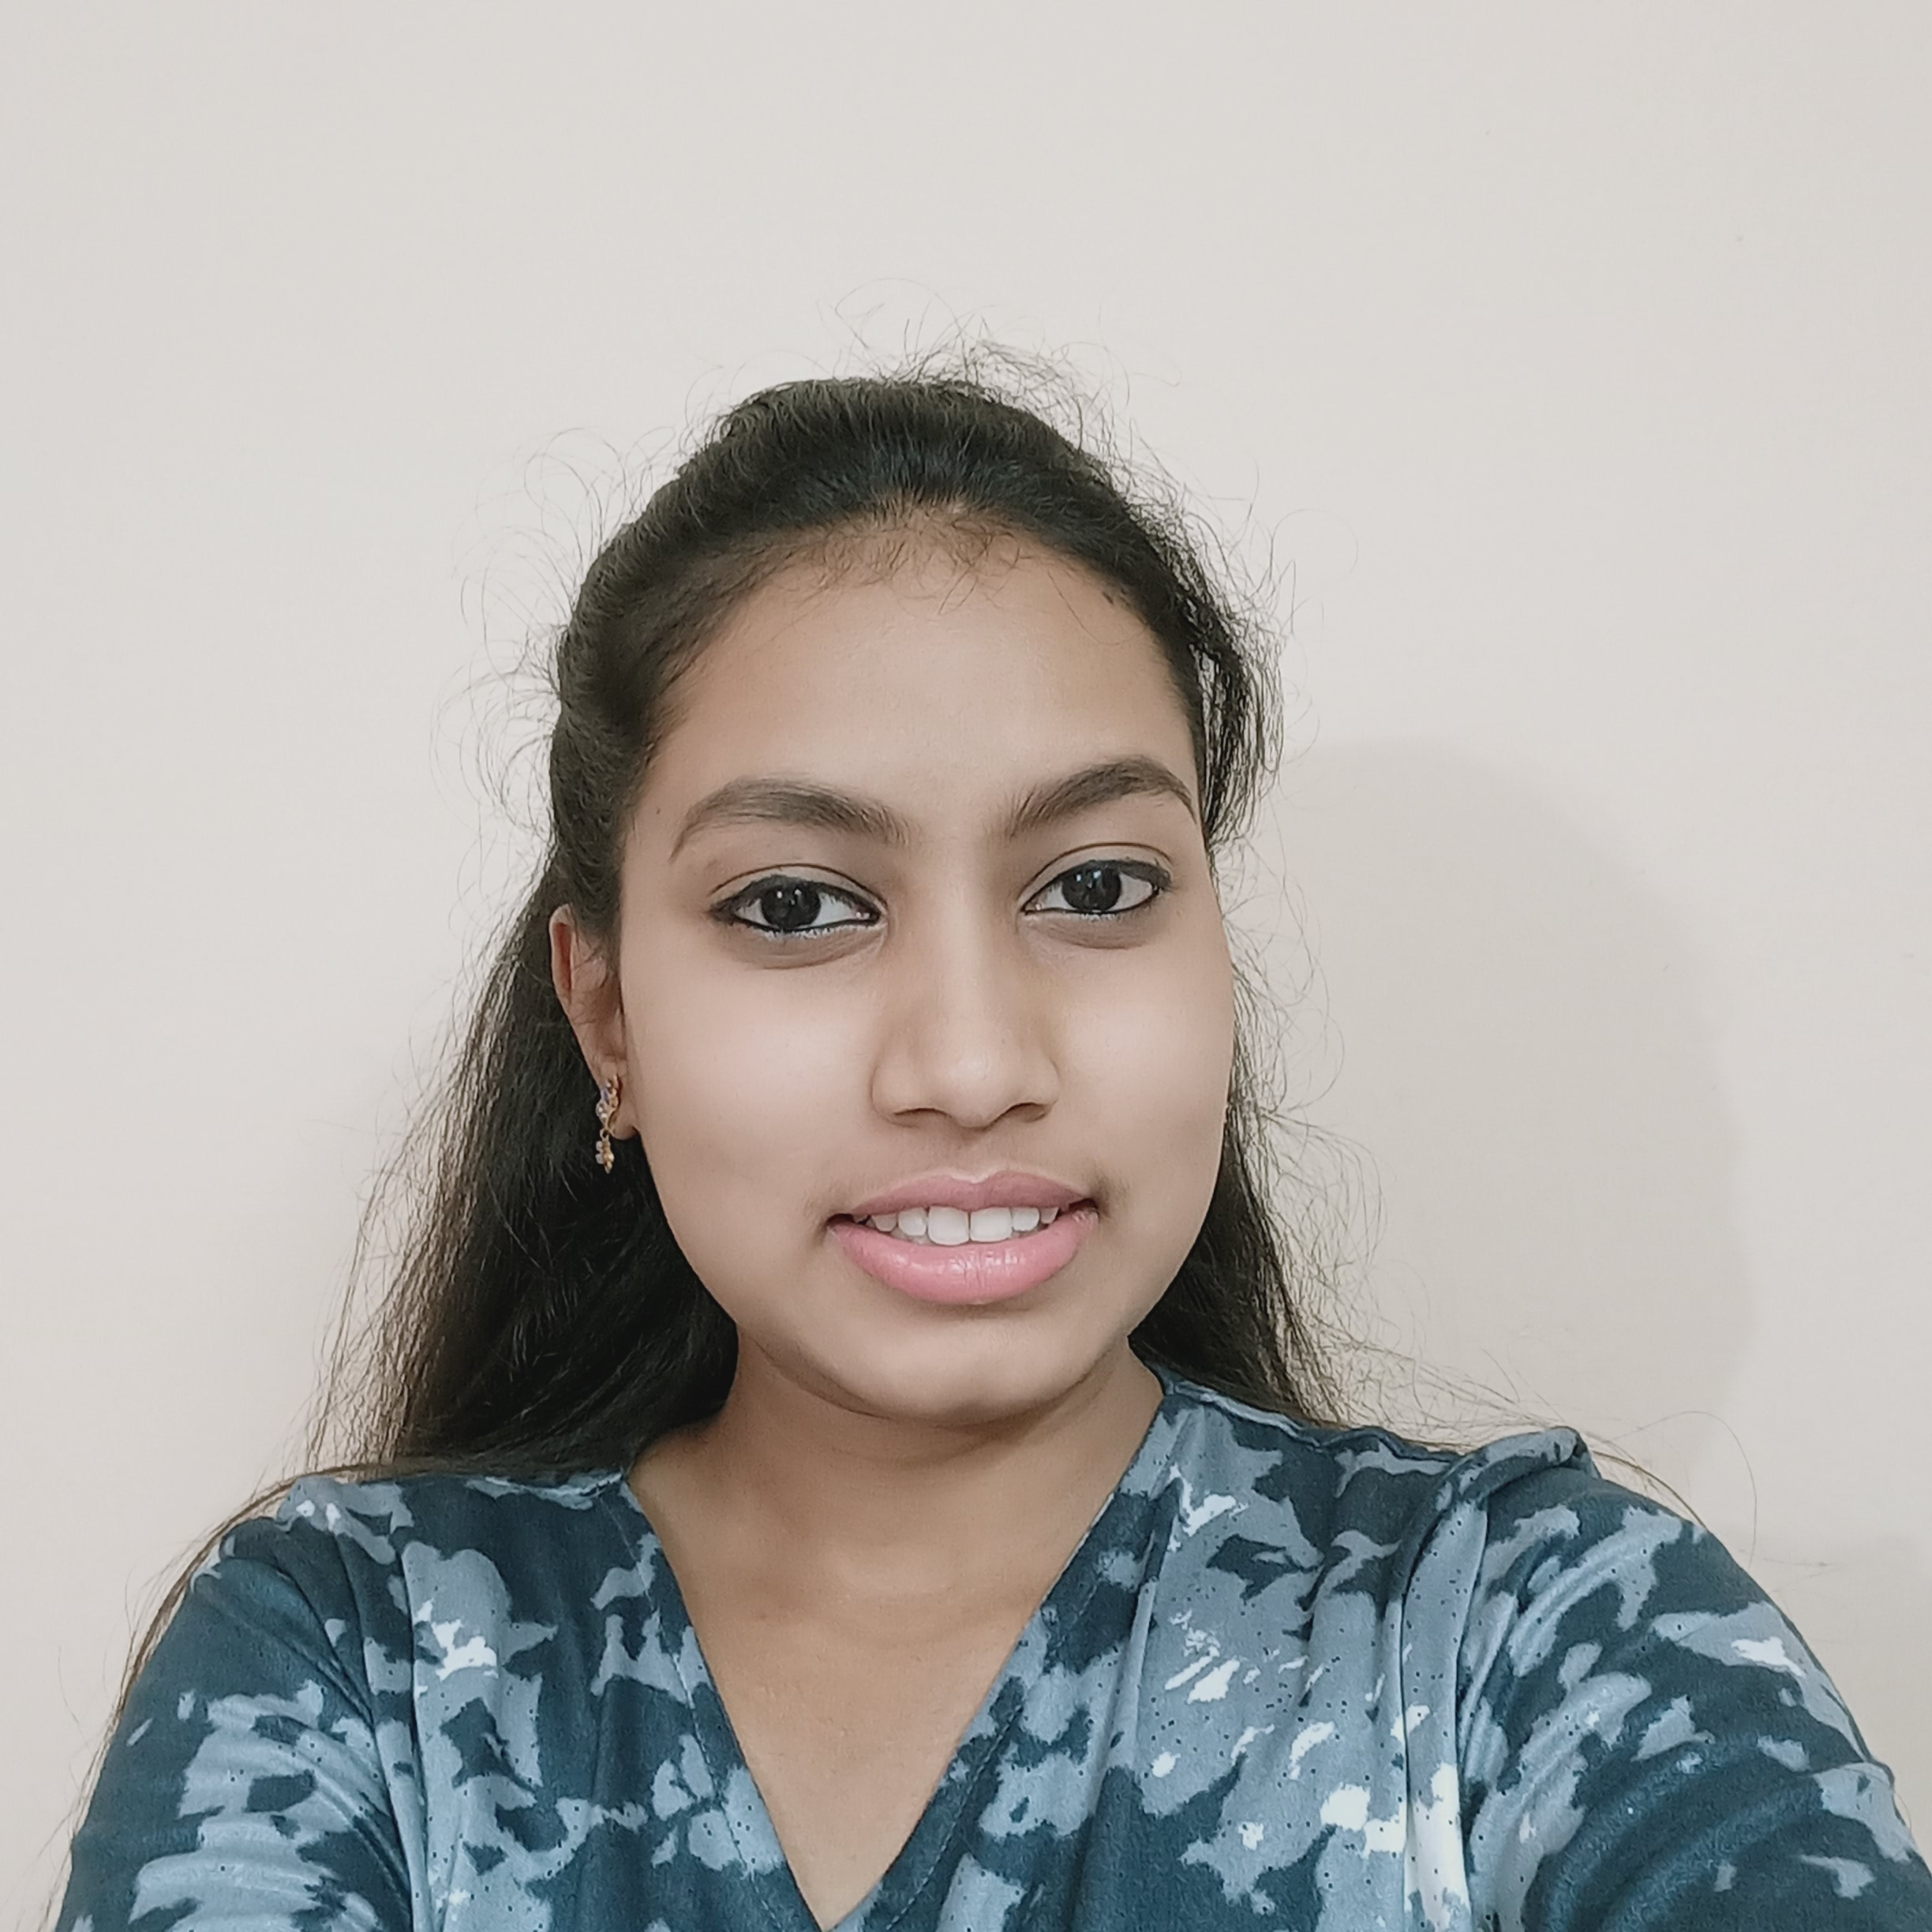

Mobile No: +91 9108682854
E-mail ID: lavanyakv133@gmail.com

Permanent address:

#76 EWS, Akashaya Bandara, New Kantharaja-urs road, Kuvempunagara,
Mysuru,
Karnataka
570023

Personal Details

Father Name: Late Venkatesh
DOB: 13-03-1997
Nationality: Indian
Gender: Female

Personal Strength

- Hard work
- Communication
- Ability to work under pressure
- Time management
- Leadership

Language

- English
- Kannada
- Hindi

PROFILE SUMMARY

Bachelor of Engineer in the stream of Mechanical Engineering. Passion about to want to become a Knowledgeable and skilled Design Engineer. To achieve this goal I ready to work 12hr a day. And I also have a good knowledge of mechanisms.
EDUCATION

BE: Mechanical Engineering at 2020 with 7.4 CGPA
Diploma: Mechanical Engineering With 72%
SSLC: At MGHS with 58%
TECHNICAL SKILLS

- Basics of GD&T
- Mechanism
- Drafting
- Bill of Material (BOM)
- Able to maintain a 7S standard
- MS Word
SOFTWARE SKILLS

- AutoCAD
- Solid works
- 2D/3D Modeling
- Drafting

INTERNSHIP & PROJECT DETAILS

DURATION | INTERNSHIP | PROJECT
1 Year | AT&S pvt ltd | Industry Project at AT&S pvt ltd
1 Month | Rane Madras pvt ltd | Hydro-engine bike at BE
Till the Date | SEIREN India Pvt. Ltd | QA

TRUTH DECLARATION

I here declare that the information furnished above is true to best of my knowledge. I declare that above particulars of information and facts stated are true, correct and complete to the best of my knowledge.

