RESUME
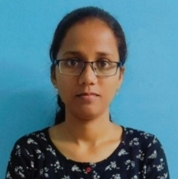
Khusbu Kumari
Address: Fancy Ali, Jorhat, Assam
Mobile no.:7086210752
Email ID: khusbukumari697@gmail.com
CARRIER OBJECTIVES:-

To get an opportunity where I can make the best of my potential and contribute to the organization’s growth.
ACADEMICS:-

Qualification | Board/University | School/College | Year of Passing | Percentage
H.S.L.C. | SEBA Board | Rashtra Bhasha Vidyalaya | 2014 | 71%
H.S. | A.H.S.E.C. Board | J.B. College | 2016 | 60.8%
B.COM. | Dibrugarh University | C.K.B.Commerce College | 2019 | 71.83%
M.COM. | Dibrugarh University | J.B. College | 2021 | 8.03 (SGPA)
PROJECTS:
Academic Project 1: E-Banking
E-bank is the electronic bank that provides the financial service for the individual client by means of internet. The terms, personal computer (PC) banking, internet banking, virtual banking, online banking, home banking, remote electronic banking, and phone banking etc., refer to one form or another of electronic banking.

- It is made with the intention to give users clear understanding of how e-banking works.
- Various data’s related to E-Banking products such as ATM, Debit cards, Credit cards, RTGS, NEFT, Mobile Banking etc. were carried out.
Academic Project 2: Business Model on E-Tailoring Business
Brief description of the Business Model:
Name of the Business: Jorhat E-Tailoring
Nature of Business: e-tailor
“Jorhat E-Tailoring Inc.” will allow those busy people to choose their customize clothes as they wish to have. In this business we will tie-up with the renowned tailors of Jorhat city and will discuss and finalize on the budget and margin front. Customers just need to register themselves on App/Website to place their order and book a tailor master to take their measurement physically as per their consent. We will also provide doorstep services to all our customers like (home pick-up and delivery services). These services will help the customers by saving their time and energy and they will be able to use these time in doing other productive work. Another service like customers can choose payment via different mediums such as Net banking, E-wallet, Cash on delivery and it will be 100% protected.
TRAINING/WORKSHOP ATTENDED
- Participated and completed the Workshop on “Innovation in Artificial Intelligence, Virtualization, and Augmented Reality” held at Jagannath Barooah College.
- Participated and completed Financial Modelling Workshop by LEAPUP EDUTECH PVT.LTD.
- Participated and completed workshop on Post Covid-19 career opportunities.
- Participated in a National Level Symposium on Reinventing and Integrating The New Era of Management and Media Practices conducted by CMS, JAIN (Deemed-to-be University), Bengaluru.
- Participated and completed workshop on Equity Trading Workshop by LEAPUP.
- Participated and completed the Workshop on “Equity Research and Long Term Investment Workshop” by LEAPUP EDUTECH PVT.LTD.
CERTIFICATIONS
- Certificate in Computer Concept (CCC) certification of duration 3 Months
- Diploma In Financial Accounting(Windows XP, Ms-Word, Ms-Excel, Ms-Powerpoint, Tally.ERP9 with GST) of duration 6 Months
OTHER SKILLS:-
- Very Good Logical and Analytical Skills.
- Excellent in Interpersonal and decision making ability.
- Quick learner.
ACHIEVEMENTS:-
- Secured First position in the event “Reading Between the Lines” organised by Leo Club of Jorhat City Stars on the occasion of National Reading Day held on 19th June, 2021.
- Participated and completed the National Level Online Quiz Competition organised by Department of M.Com, in association with IQAC, K.C.Das Commerce College.
- Participated and well performed in “E-Quiz on Capital Markets” organised by Finmark Trainers India Pvt Ltd.
- Participated and qualified in Online Quiz on the “World Environment Day” organised by IQAC, Public College of Commerce, Dimapur-Nagaland held on 5th June, 2021.
PERSONAL VITAE:-
Name : Khusbu Kumari
Date of Birth : 6th November 1998
Hobbies : Reading, Playing Badminton
Language Known : English, Hindi and Assamese
Marital Status : Unmarried
Nationality : Indian
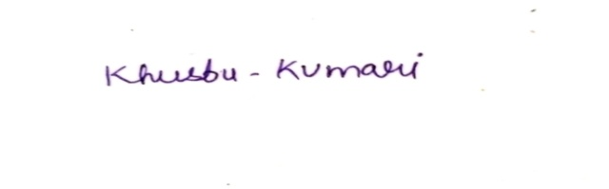
DECLARATION:-
I hereby declare that all the above information is correct and true to the best of my knowledge.
Place- Jorhat Signature-

