CURRICULUM VITAE
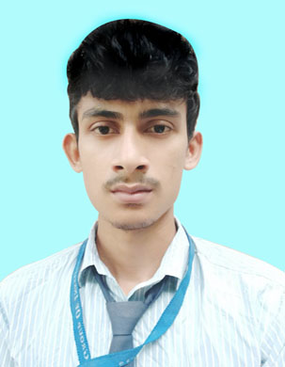

- PERSONAL PROFILE:

- NAME :SUKALYAN DAS
- FATHER’S NAME : DIPAK DAS
- DATE OF BIRTH : 5TH – SEP - 1999
- PERMANENT ADDRESS : VILL – BARAKALANKAI
PO – BARAKALANKAI
PS – NARAYANGARH
DIST – PASCHIM MEDINIPUR
PIN -721437, WEST BENGAL
- PRESENT ADDRESS : SAME AS ABOVE
- CONTACT NO. : 6294591914 / 8348494365
- E-MAIL : dassukalyan9@gmail.com
- LANGUAGE KNOWN : BENGALI, ENGLISH, HINDI
- CATEGORY : GENERAL
- NATIONALITY : INDIAN
- RELIGION : HINDUISM
- SEX : MALE

- CARRIER OBJECTIVES: BY USING GOOD MANAGEMENT, TEAM HANDING AND LEADERSHIP SKILLS, WORK WITH AN ORGANIZATION FOR THE MUTUAL PROFIT AND GROWTH.

- EDUCATIONAL QUALIFICATION:

EXAM PASSED | BOARD/UNIVERSITY | YEAR OF PASSING | TOTAL MARKS | MARKS OBTAINED | PERECENTAGE OF MARKS
SECONDARY | W.B.B.S.E | 2015 | 700 | 465 | 66.42%
HIGHER SECONDARY | WB.C.H.S.E | 2017 | 500 | 329 | 65.8%
B.B.A | M.A.K.A.U.T | 2021 | - | - | 8.07 DGPA

- EXTRA QUALIFICATION:

NAME OF COURSE | NAME OF INSTITUTION | YEAR OF PASSING | GRADE
DIPLOMA IN COMPUTER APPLICATION (DCA) | RAJEEV GANDHI YOUTH COMPUTER SAKSHARATA MISSION | 2017 | A+
- INTERNSHIP: Completed 3 month internship from FUTURE GROUP subject name “Study on analyzing promotional tactics in retail sector”

- STRENGTHS: HARD WORKING, GOOD MANAGEMENT SKILLS, TEAM LEADING & LEADERSHIP, GOOD COMMUNICATION SKILLS, POSITIVE ATTITUDE.

- HOBBIES & INTEREST: READING STORY BOOKS & REVIEWING MOVIES.

- DECLEARATION:I, HERE DECLARED THAT THE STATEMENT MADE IN ABOVE ARE TRUE COMPLICATION AND CORRECT TO THE BEST OF MY KNOWLEDGE & BELIEF.



……………………………………….
DATE: 9th– DEC – 2021 SIGNATURE

