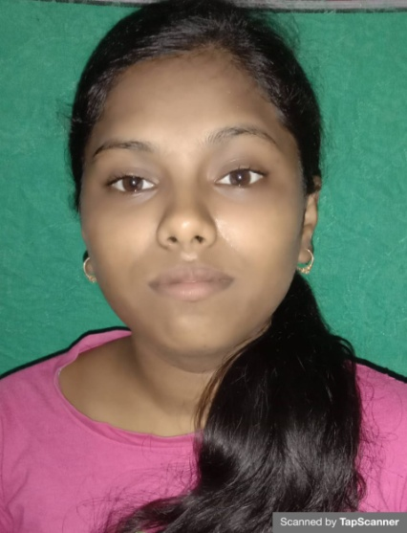

RESUME
MAMATA DAS
At-Rampur
Po-Ramakrushnapur
Via-Barapada
Dist-Bhadrak
ODISHA
Pin-756113
Mob-7327084016

OBJECTIVE
To work in a challenging atmosphere this provides opportunity to grow and learning to be a part of this global organization and became the individual player to prove myself worthy and efficient to this job. I will work full dedication and strengths. Given an opportunity I will face challenge with determination and grit.
PERSONAL PROFILE
- Father’s Name : Sambhunath Das
- Mother’s Name : Barsa Das
- Date of Birth : 19\06\1997
- Sex : Female
- Marital Status : Single
- Religion : Hindu
- Language Known : Odia, English & Hindi

EDUCATIONAL QUALIFICATION
- Graduate in Botany honors with PGDCA
EXPERIENCE
Three years experience working as Data Entry Operator (DEO)
HOBBIES
- Listening Music
- Watching News
- Making Friendship with others and Helpful Good Relation.
- Reading Books

SKILL AND ABILITY
- Hard and Smart working
- Ability to Co-operate with different situation
- Problem solving skill
- Excellent Communication skill
GOAL
- To work in where I will get exposure to my future career as well as my creative qualities.
DECLARATION
I do hereby declare that all the above statements made in this application are true correct & complete to the best of my knowledge and belief.

Place :
Signature of Applicant
Date :

